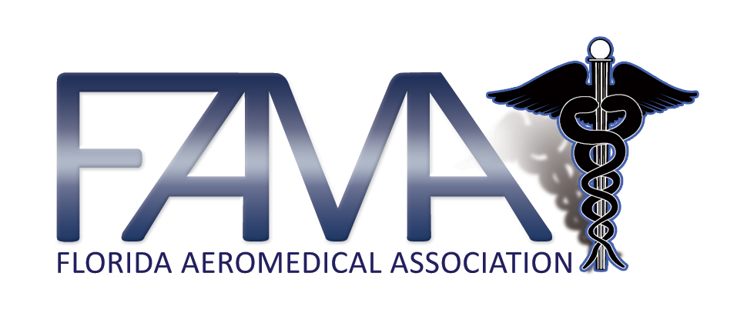
Daytona Beach, Florida
January 21, 1000 - 1200
Agenda

- Call to Order B Conte

- Moment of Silence B Conte

- Standing Reports

  - President’s Report/EMSAC B Conte
  - Bureau Report S McCoy
  - State Medical Director Dr. J Nelson
  - AAMS G Pagano
  - Strategic Plan J Bacon

- Business

  - Bylaws and Position Update B Conte
    - Vice President
    - Treasurer
    - Board Positions
  - Membership J Bacon
  - Safety Summit – April 13, Gainesville M Thomas
  - C-NPT Review – April 14, Gainesville B Bailey
  - Rule Workshop Update B Conte
  - Next Meeting

Air Medical Group Breakout

- Groups to meet separately if needed

  - FNPTNA
  - Florida Pilots

- Adjournment

