Arbovirus Surveillance:

Serology Request Form- Sentinels



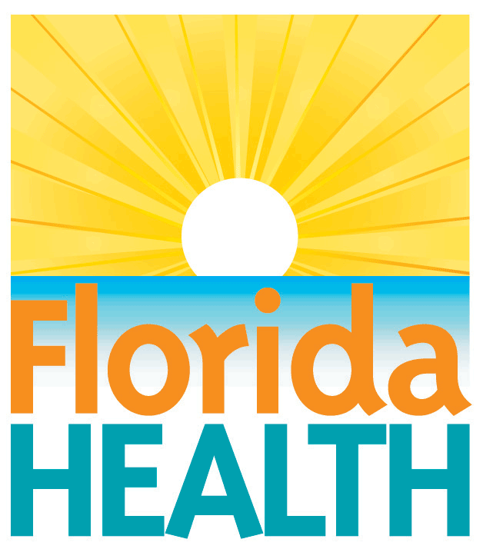

|  |  |
| --- | --- |
| **DOH LAB USE ONLY** | |
| Date Received: |  |
| Date Reported: |  |
| **HAI (Flavivirus/Alphavirus)** | |
| Bureau of Public Health Labs-Tampa Contact:  Ms. Maribel Castaneda  Phone: 813-233-2342  Fax: 813-233-2380  E-mail: [Maribel.Castaneda@flhealth.gov](mailto:Maribel.Castaneda@flhealth.gov) or  Lea.Heberlein-Larson@flhealth.gov | |

|  |  |
| --- | --- |
| **Submitter Information** | |
| Name: |  |
| E-mail: |  |
| Phone number: |  |
| Fax number: |  |
| Organization: |  |
| Address: |  |
| City: |  |
| State: |  |
| Zip Code: |  |
| County: |  |

|  |  |  |  |  |  |  |  |
| --- | --- | --- | --- | --- | --- | --- | --- |
| **Specimen Collection Data** | | | | **DOH LAB USE ONLY** | **TITER** | |  |
| **Collection Date** | **Bird #** | **Site** | **New** | **LAB NUMBER** | **Flavi\*** | **Alpha\*** | **Notes** |
| 1. |  |  |  |  |  |  |  |
| 2. |  |  |  |  |  |  |  |
| 3. |  |  |  |  |  |  |  |
| 4. |  |  |  |  |  |  |  |
| 5. |  |  |  |  |  |  |  |
| 6. |  |  |  |  |  |  |  |
| 7. |  |  |  |  |  |  |  |
| 8. |  |  |  |  |  |  |  |
| 9. |  |  |  |  |  |  |  |
| 10. |  |  |  |  |  |  |  |
| 11. |  |  |  |  |  |  |  |
| 12. |  |  |  |  |  |  |  |

*Flavivirus includes SLE & WN; Alphavirus includes EEE and HJ

This form must accompany all serum specimens submitted for serologic examination. Submitter should fill out the left side of the form completely. Do not skip lines when listing collected specimens. If the bird is new to the flock or bled for the first time, place an X in the New column. Please contact us if there are any questions.