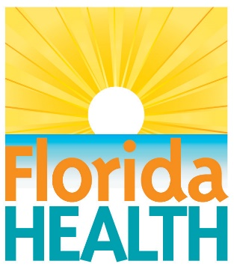
FOR IMMEDIATE RELEASE
July 2, 2021

health officials issue Blue-Green Algae Bloom ALERT for the

davis boat ramp
Contact:
Tammy Soliz, Lee PIO
Lee-pio@flhealth.gov
(239) 308-5196
Fort Myers, FL The Florida Department of Health in Lee County has issued a Health Alert for the presence of harmful blue-green algal toxins at the Davis Boat Ramp. This is in response to a water sample taken on June 29, 2021. The public should exercise caution in and around the Davis Boat Ramp.
Residents and visitors are advised to take the following precautions:
- Do not drink, swim, wade, use personal watercraft, water ski or boat in waters where there is a visible bloom.
- Wash your skin and clothing with soap and water if you have contact with algae or discolored or smelly water.
- Keep pets away from the area. Waters where there are algae blooms are not safe for animals. Pets and livestock should have a different source of water when algae blooms are present.
- Do not cook or clean dishes with water contaminated by algae blooms. Boiling the water will not eliminate the toxins.
- Eating fillets from healthy fish caught in freshwater lakes experiencing blooms is safe. Rinse fish fillets with tap or bottled water, throw out the guts and cook fish well.
- Do not eat shellfish in waters with algae blooms.

What is blue-green algae?
Blue-green algae are a type of bacteria that is common in Florida’s freshwater environments. A bloom occurs when rapid growth of algae leads to an accumulation of individual cells that discolor water and often produce floating mats that emit unpleasant odors.
Some environmental factors that contribute to blue-green algae blooms are sunny days, warm water temperatures, still water conditions and excess nutrients. Blooms can appear year-round but are more frequent in summer and fall. Many types of blue-green algae can produce toxins.

Is it harmful?
Blue-green algae blooms can impact human health and ecosystems, including fish and other aquatic animals.
For additional information on potential health effects of algal blooms, visit floridahealth.gov/environmental-health/aquatic-toxins.
Find current information about Florida’s water quality status and public health notifications for harmful algal blooms and beach conditions by visiting ProtectingFloridaTogether.gov. Protecting Florida Together is the state’s joint effort to provide statewide water quality information to prioritize environmental transparency and commitment to action.
What do I do if I see an algal bloom?
The Florida Department of Environmental Protection collects and analyzes algal bloom samples. To report a bloom to DEP, call the toll-free hotline at 855-305-3903 or report online.

To report fish kills, contact the Florida Fish and Wildlife Research Institute at 1-800-636-0511.

Report symptoms from exposure to a harmful algal bloom or any aquatic toxin to the Florida Poison Information Center, call 1-800-222-1222 to speak to a poison specialist immediately.

Contact your veterinarian if you believe your pet has become ill after consuming or having contact with blue-green algae contaminated water.

If you have other health questions or concerns about blue-green algae blooms, please call the Florida Department of Health in Lee County at (239) 690-2100.

####
About the Florida Department of Health
The department, nationally accredited by the Public Health Accreditation Board, works to protect, promote and improve the health of all people in Florida through integrated state, county and community efforts.
Follow us on Facebook, Instagram and Twitter at @HealthyFla. For more information about the Florida Department of Health please visit www.FloridaHealth.gov.

