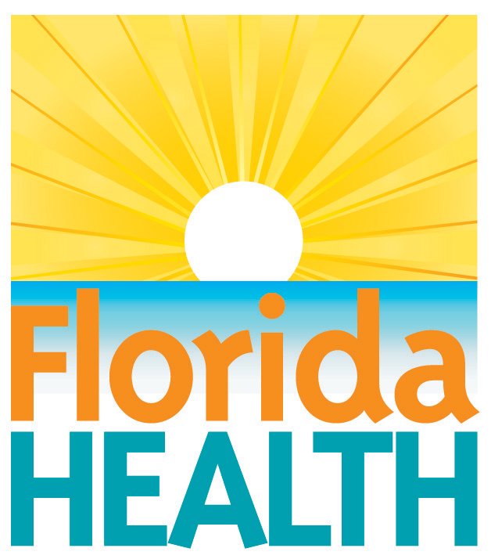
July 16, 2021

Red Tide Present in the Gulf
Health Alert for Boca Grande Beach

Contact:
Tammy Soliz, Public Information Officer
Lee-Pio@flhealth.gov
239-308-5196

Lee County, Fla. -The Florida Department of Health in Lee County (DOH-Lee) is notifying the public of a red tide bloom near Boca Grande Beach. Some people may have mild and short-lived respiratory symptoms such as eye, nose, and throat irritation similar to cold symptoms. Some individuals with breathing problems such as asthma might experience more severe symptoms. Usually symptoms go away when a person leaves the area or goes indoors. Health officials recommend that people experiencing these symptoms stay away from beach areas or go into an air-conditioned space. If symptoms do not subside, please contact your health care provider for evaluation.
The Department recommends that you:
- Do not swim around dead fish at this location.
- If you have chronic respiratory problems, be careful and consider staying away from this location as red tide can affect your breathing.
- Do not harvest or eat molluscan shellfish and distressed or dead fish from this location. If fish are healthy, rinse fillets with tap or bottled water and throw out the guts.
- Keep pets and livestock away from water, sea foam and dead sea life.
- Residents living in beach areas are advised to close windows and run the air conditioner (making sure that the A/C filter is maintained according to manufacturer's specifications).
- If outdoors, residents may choose to wear paper filter masks, especially if onshore winds are blowing.
Florida Poison Control Centers have a toll-free 24/7 Hotline for reporting of illnesses, including health effects from exposure to red tide at 1-800-222-1222.
Please visit the Florida Fish and Wildlife Research website for additional information on the locations where red tide has been found: myfwc.com/research/redtide/statewide/.
About the Florida Department of Health
The Department, nationally accredited by the Public Health Accreditation Board, works to protect, promote and improve the health of all people in Florida through integrated state, county and community efforts.
Follow us on Facebook, Instagram and Twitter at @HealthyFla. For more information about the Florida Department of Health please visit www.FloridaHealth.gov.

