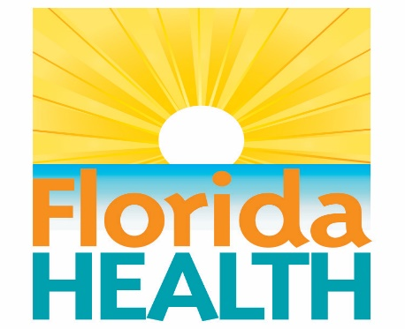

APPROVED BODY PIERCING COURSE
$100.00 Per Person

Certificate of Completion - Upon completion of class you will receive
certificate of completion. All Body Piercers are required to attend an annual
training class. Pre-registration required
This course meets the requirements of F.A.C. 64E-19.
Registration is Easy
1. WHERE: Florida Department of Health- Duval County
900 University Blvd. N., 1st floor conference room
Jacksonville, Fl 32211
WHEN: Monday, July 12th, 2021 9am – 1pm
2. CHOOSE YOUR METHOD OF REGISTRATION
PHONE (904) 253-2578 (pay by credit card) Email Registration Form to: Cassandra.haverkamp@flhealth.gov
3. CHOOSE YOUR METHOD OF PAYMENT
Mail: Check or money order in the amount of $100, payable to:
Florida Department of Health- Duval County, 900 University Blvd. North, Suite
300 Jacksonville, FL 32211 or fax registration form to 253-2390 and call 253-2578
to pay by credit card over the phone.
4. REGISTRANT INFORMATION
(One registrant per form- please print or type)

FIRST NAME _____________________________________________

LAST NAME ______________________________________________

BUSINESS NAME _________________________________________

ADDRESS ________________________________________________

CITY _______________________________

ZIP CODE ___________________________

TELEPHONE __________________________________

OTHER ______________________________________

