Important Announcement
ACIP Immunization Schedule Updated to Include
16-Year-Old Immunization Platform Visit

ATTN: [INSERT VFC PROVIDER NAME HERE – EXAMPLE ‘ABC PEDIATRICS’]:

The CDC and the Advisory Committee on Immunization Practices (ACIP) recently introduced the 2017 Childhood and Adolescent Immunization Schedule, which now highlights a specific 16-year-old immunization platform visit.¹ This schedule change emphasizes the need to consider the 16-year-old visit as an immunization “platform,” which should include vaccination among the other preventive care services offered to this age group.

The State of (Insert State Name Here) is supporting the 16-year-old immunization platform visit by committing to vaccinate as many eligible adolescents as possible. Please implement the following steps within your practice:

- Establish a routine 16-year-old visit for all adolescent patients. This visit will prioritize vaccinating all eligible patients with the following:

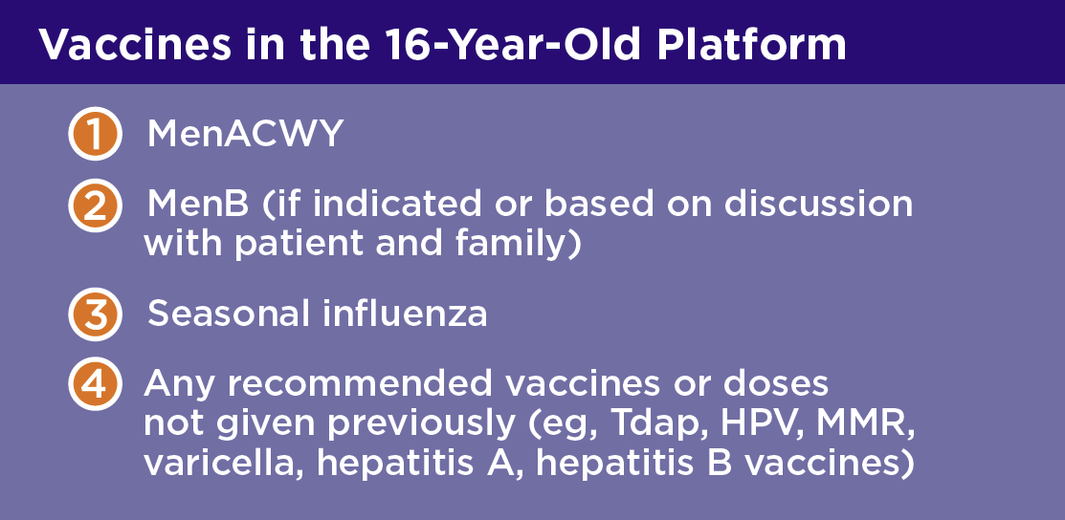

- Review medical records and identify 16-year-old patients who are due for immunizations.

- Send reminders and recall notices to eligible 16-year-old patients to schedule their visit.

- Educate all 16-year-old patients about vaccine-preventable diseases.

- Consider every 16-year-old visit as a vaccination opportunity.

Thank you for your attention to this matter. We look forward to implementing these efforts with your help.

Sincerely,
[INSERT NAME HERE]

Reference:
- Centers for Disease Control and Prevention (2017). Recommended immunization schedule for children and adolescents aged 18 years or younger, United States, 2017. https://www.cdc.gov/vaccines/schedules/downloads/child/0-18yrs-child-combined-schedule.pdf. Assessed May 22, 2017.

