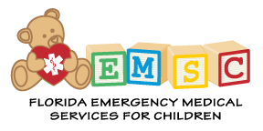

EMSC ADVISORY COMMITTEE
January 19, 2017
1:00 p.m. – 4:00 p.m.
Daytona Beach, FL
GENERAL
- Welcome & Sign-In

- Updates

REPORTS
- State Update S McCoy
- EMS State Plan C Richter
- Education M Rushing
- Medical/EMS Lou Romig
- State Medical Director J Nelson
- National Performance Measures Planning

PROJECTS 2017
- Federal QI Collaborative

- 2017 EMS Week/EMSC Day

NEXT MEETING
- Conference Call - February 15, 2017

10:00 a.m. – 11:00 a.m.

