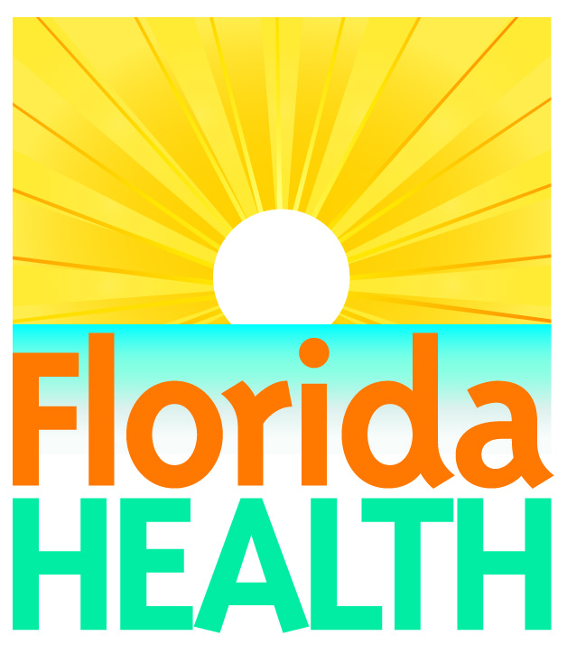
 | FLORIDA DEPARTMENT OF HEALTH  EMERGENCY MEDICAL SERVICES (EMS) SECTION  STATE EMS AWARDS | 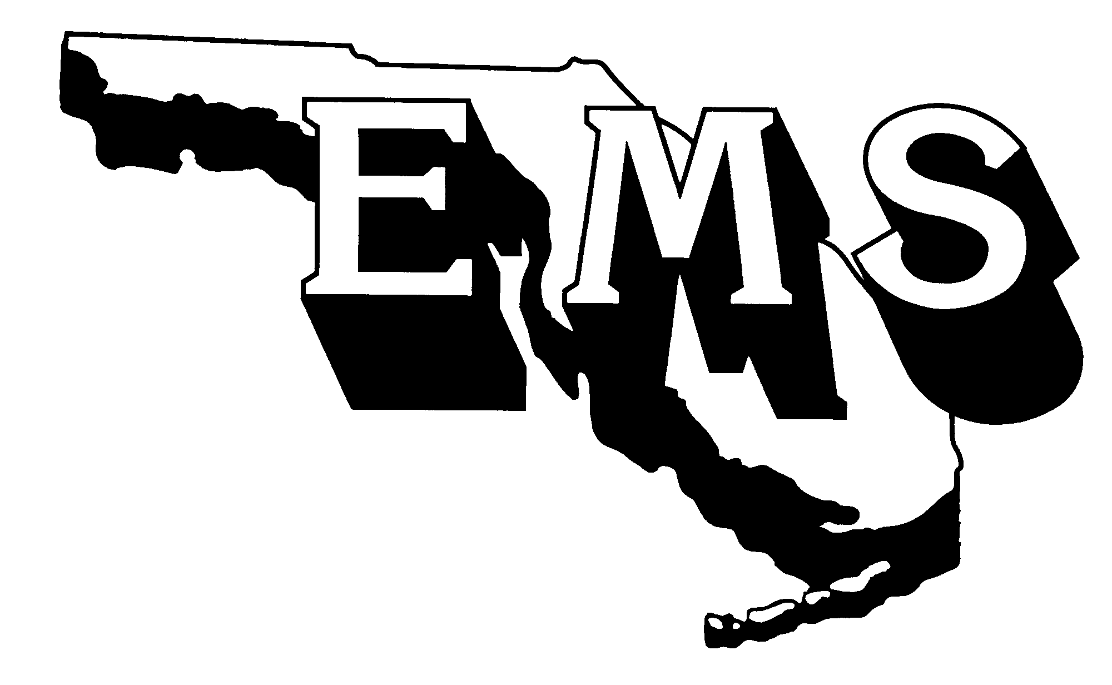

2016 AWARD CATEGORIES
- Emergency Medical Technician (EMT)
- Paramedic
- 911 Public Safety Telecommunicator
- EMS Disaster Preparedness & Response
- EMS Provider
- EMS Education (individual or organization)
- EMS for Children (individual or organization)
- Injury Prevention
- Larry S. Jordan - EMS Hall of Fame
- Raymond H. Alexander - EMS Medical Direction
- Marilyn Crook EMS Pioneer Award
- EMS Nursing
- Photo and/or Video (individual or organization)
- Friend to EMS (individual or organization)
- EMS Memorial

REVIEW CRITERIA
The following criteria will be used to evaluate nominations for the State EMS Awards:

Emergency Medical Technician
This award recognizes an EMT who:
- is a non-administrative, certified EMT whose primary job is direct patient care;
- currently has no administrative action pending from the Department of Health;
- has demonstrated exceptional qualities in one or more of the following areas: quality assurance/improvement, patient care, medical control, disaster preparedness, or public education and/or training; and
- has acted “above and beyond the call of duty” in response to the EMS community and/or profession (please elaborate as to how the individual exceeded normal day-to-day job functions while on duty).

Paramedic
This award recognizes a paramedic who:
- is a non-administrative, certified paramedic whose primary job is direct patient care;
- currently has no administrative action pending from the Department of Health;
- has demonstrated exceptional qualities in one or more of the following areas: quality assurance/improvement, patient care, medical control, disaster preparedness, or public education and/or training; and
- has acted “above and beyond the call of duty” in response to the EMS community and/or profession (please elaborate as to how the individual exceeded normal day-to-day job functions while on duty).

911 Public Safety Telecommunicator
This award recognizes an individual who:
- has demonstrated outstanding effort in processing a medical emergency call; and
- has demonstrated outstanding efforts in educating the public on 911.

A copy of the nominee processing a call must be included within your submission

EMS Disaster Preparedness & Response
This award recognizes an individual (or organization) who:
- currently has no administrative action pending from the Department of Health;
- has demonstrated exceptional proficiency in developing response plans and/or has been instrumental in ensuring successful emergency or disaster response;
- works in the area of emergency medical planning or response;
- has made a significant contribution in helping Florida prepare for health/medical response to significant emergencies or disasters;
- has demonstrated leadership and initiative in the areas of emergency medical preparedness, education, and response;
- is known as an “innovator” for developing successful ideas or programs to facilitate a successful health/medical response to emergencies or disasters; and
- has been an active participant in organizations, task groups, or committees whose mission is to enhance disaster medical response throughout Florida.

EMS Provider
This award recognizes a licensed EMS provider that:
- participates in the Florida Prehospital EMS Tracking and Reporting System (EMSTARS);
- currently has no administrative action pending from the Department of Health;
- has assumed a leadership role in the Florida EMS system and community;
- has demonstrated outstanding initiative in the area of public education and/or training; and
- has demonstrated excellence in the areas of quality assurance/improvement and medical control protocol development/implementation.

EMS Education
This award recognizes an individual (or organization) who:
- is recognized as an educator of a Florida EMS training program, Florida approved continuing education provider, or licensed EMS service;
- has assumed a leadership role in the field of EMS education;
- has made a positive contribution to EMS education in the community, state, or nation; and
- currently has no administrative action pending from the Department of Health.

EMS for Children
This award recognizes an individual (or organization) who:
- has demonstrated outstanding achievement in pediatric education;
- has a comprehensive understanding of the unique needs of the pediatric patient;
- has successfully integrated pediatric issues into current disaster management efforts;
- has assumed a leadership role in EMSC within the community, state, or nation;
- has made a significant contribution (e.g., development of product or program) that has improved emergency care for children and their families; and
- currently has no administrative action pending from the Department of Health.

Larry S. Jordan - EMS Hall of Fame
This award recognizes an individual who:
- is viewed as a national advocate for EMS, increasing public attention and action at the highest levels;
- has devoted a significant part of his/her life to promoting and advancing prehospital emergency care;
- has worked to change the manner in which we care for patients throughout the entire continuum of care;
- has been active on numerous committees and boards at the state and national levels;
- has had EMS related works published in journals, textbooks, and/or other publications;
- has a minimum of 20 years experience in the field of EMS; and
- currently has no administrative action pending from the Department of Health.

Raymond H. Alexander - EMS Medical Direction
This award recognizes an individual who:
- is a licensed Florida physician;
- has assumed a leadership role in EMS within the community, state, or nation;
- has demonstrated excellence in the areas of quality assurance/improvement and medical control;
- has successfully promoted the use of new medical trends and technologies; and
- currently has no administrative action pending from the Department of Health.

Marilyn Crook EMS Pioneer Award
This award recognizes an individual who has advanced the EMS profession and/or system:
- through visionary leadership:
  - by setting directions and creating patient focus, clear and visible values, and high expectations while balancing the needs of all EMS stakeholders; and
  - by ensuring the creation of strategies, systems, and methods for achieving performance excellence, stimulating innovation, building knowledge and capabilities, and ensuring EMS sustainability.
- through managing for innovation. Innovation means making meaningful change to improve EMS products, services, programs, processes, and operations and to create new value for EMS stakeholders; and
- by promoting the use of best practices by building internal and external partnerships to address common issues, enhance communication, and evaluate progress to adapt to changing conditions in the EMS system.

EMS Nursing
This award recognizes an individual who:
- is currently a licensed registered nurse;
- has provided leadership in the area of emergency medical services;
- currently has no administrative action pending from the Department of Health; and
- has demonstrated independent initiative in one or more of the following areas: education, clinical care, community service, or disaster management.
EMS Injury Prevention
This award recognizes an individual who:
- currently holds Florida certification as an EMT/Paramedic or is a licensed RN or physician that is employed with a licensed EMS agency pursuant to Chapter 401, F.S.;
- currently has no administrative action pending from the Department of Health;
- has demonstrated outstanding initiative and promoted best practices to prevent injuries in at least one area of injury prevention, such as motor vehicle safety, drowning, falls or burn prevention, etc.;
- has been active on injury prevention committees, task forces, or boards at the local, state and/or national level;
- responds to injury problems within communities by regularly going beyond duties as assigned; and
- successfully integrated injury prevention issues into emergency care efforts.

Photo and/or Video
This award recognizes an individual (or organization) who submits a photo (color or black & white) and/or video that clearly depicts the 2016 National EMS Week theme: "EMS STRONG: Called to Care." Amateur and professional photographs/videos accepted.

In order to be considered, all color and black and white photo submissions must include the attached release form signed by the submitting agency and/or the individuals in the photos.

Friend to EMS
This award recognizes an individual (or organization) that is not employed with an EMS organization, but has successfully enhanced EMS through their partnership or promotion of EMS activities such as preparedness, injury prevention, or other initiatives.

EMS Memorial
This award recognizes an individual who has lost his/her life in the line of duty. Please report any of these unfortunate casualties to the EMS program that occurred after January 2015. These individuals will be recognized for their sacrifice at the awards ceremony and be inducted into the EMS Memorial in Tallahassee.

REVIEW PROCESS
An awards selection committee comprised of EMS staff will review nominations and supporting documentation and make award recommendations to the EMS section administrator. The committee reserves the right to forgo the presentation of an award if an appropriate candidate is not identified.

PRESENTATION OF AWARDS
Recipients of each award category will be notified prior to National EMS Week. Award notification letters will be mailed to award recipients, as well as the individual or organization who nominated them. Each recipient will be honored at an evening award ceremony sponsored by the Emergency Medicine Learning & Resource Center in conjunction with the EMS Advisory Council and Constituent Group Meetings and ClinCon. The ceremony will be held on July 13, 2016 at 5:30 p.m.

APPLICATION PROCESS
To nominate an individual or organization please submit the following:

Nomination Entry Sheet: Please complete the attached nomination entry sheet and indicate the award for which you are applying.

Summary Statement Guidelines: Prepare a statement to depict the nominee’s qualities and contributions to EMS in Florida. Include why the nominee is exceptionally qualified and should be selected for this award. Break down the nomination criteria by specifics and describe how the nominee has excelled in each area specified in the criteria. Be specific. If you do not address EACH component of the nomination, you will lose points.

****This does not apply to the photo and video categories. Simply submit the photo or video with the signed release form(s) and describe the event in the photo or video.

Supporting Materials: Supporting materials can include articles, letters, résumé (if necessary) and any additional information to support the candidate’s nomination.

Electronic Photograph: You MUST submit an electronic photograph (high resolution JPEG) of the nominee and include the attached photo release form completed and signed by that individual or organization. This photo will be incorporated into the awards ceremony in the event the nominee is selected as a winner.

CHECK FOR ALL OF THE FOLLOWING ITEMS BEFORE YOU SUBMIT THE NOMINATION:

_____ Selected the most appropriate category for the nominee
_____ Nomination form and support materials included
_____ Electronic photograph (high resolution JPEG) of nominee enclosed
_____ Signed release form(s) enclosed for all photos or videos submitted
_____ Summary statement follows the guidelines listed above

****Failure to provide ALL the necessary information will lead to the disqualification of the nominee.

DEADLINE
All applications must be e-mailed or postmarked by March 31, 2016. Mail materials to:

Bethany Lowe, State Awards Coordinator
Bureau of Emergency Medical Oversight
4052 Bald Cypress Way, Bin A22
Tallahassee, FL 32399-1722

Or email documents to her at:
Bethany.Lowe@flhealth.gov

FLORIDA DEPARTMENT OF HEALTH
EMERGENCY MEDICAL SERVICES SECTION
STATE EMS AWARDS
2016 NOMINATION ENTRY SHEET

Check only one category for each nomination. Nominate only one person, agency or organization.

____Emergency Medical Technician (EMT) ____Marilyn Crook EMS Pioneer Award
____Paramedic ____EMS Nursing
____911 Public Safety Telecommunicator ____Photo and/or Video
____EMS Disaster Preparedness & Response ____Friend to EMS
____EMS Provider ____EMS Memorial
____EMS Education
____EMS for Children
____Injury Prevention
____Larry S. Jordan - EMS Hall of Fame
____Raymond H. Alexander - EMS Medical Direction

Nominee’s Name: ________________________________________________________

Organization (if applicable):________________________________________________

Address: _________________________________________________________________

City: ______________________________________________Zip:___________________

Phone: ______________ Fax: ____________________E-mail: __________________

NOMINATION SUBMITTED BY:

Nominator’s Name: ________________________________________________________

Organization (if applicable):_________________________________________________

Address: __________________________________________________________________

City: ____________________________________Zip:______________________________

Phone: _________________Fax:_________________ E-mail: ________________________

Prepare a summary statement describing how the nominee meets the award criteria. Please refer to the summary statement guidelines on page five.

All applications must be emailed or postmarked by March 31, 2016. Mailed materials (see checklist on page five) should be sent to:

Bethany Lowe
Bureau of Emergency Medical Oversight
4052 Bald Cypress Way, Bin A22
Tallahassee, Florida 32399-1722
(850) 245-4055 / Fax: (850) 488-9408
E-mail: Bethany.Lowe@flhealth.gov
Florida Department of Health
Internet, Intranet Release Form

Photo/Digital Image (Attach printed copy) Sound Recordings Video Clips

Description: _2016 EMS State Awards Ceremony____________________________________________

I hereby give my informed written consent for the above described photographs, digital images, sound recordings, or video clips of me to be used specifically on the Florida Department of Health Internet or Intranet web sites.

It is my understanding that the Florida Department of Health may use such material until I revoke this authorization in writing and submit it to the Internet or Intranet Webmaster.
____________________________________________________________________________________
Name (Print: Last Name, First Name, Middle Initial)
Address:_____________________________________________________________________________
____________________________________________________________________________________
____________________________________________________________________________________
Telephone Number (including area code):__________________________________________________

____________________________________________________________________________________
If applicable, print name of Parent or Legal Guardian (Last Name, First Name, Middle Initial)

Signature: ________________________________________Date:_________________________
(Signature of Parent or Legal Guardian required if under 18 years of age)
____________________________________________________________________________________
Witness Name (Print: Last Name, First Name, Middle Initial)
____________________________________________________________________________________
Witness Signature
_ _ _ _ _ _ _ _ _ _ _ _ _ _ _ _ __ _ _ __ _ _ __ _ _ _ __ _ _ _ _ _ _ _ _ _ _ _ _ _ __ _ _ __ _ _ __ _ _ _ _

I am revoking this consent. Date: ____________________________

I understand that I may only revoke consent for items that I have provided permission, and that every effort will be made to remove the item from the site within a reasonable time frame. I also understand that this file may have been copied without permission and I agree not to hold the Department of Health responsible for instances of these violations. The Department of Health agrees to remove from the site as many copies of the item as possible; however, if a copy is located within the site after the fact, I may provide the written URL, address, location, or other appropriate information to have it removed.

Signature: _____________________________________________________________________
(Signature of Parent or Legal Guardian required if under 18 years of age)

