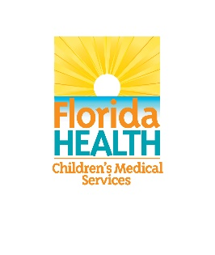
Child Forensic Interview Advisory Committee Meeting
November 19, 2020
1:00PM – 5:00PM
Join Microsoft Teams Meeting
Agenda
1:00PM – 1:15PM | Welcome & Roll Call | Jay Howell, Chair
1:15PM – 1:30PM | Review and Approval of Previous Meeting Minutes | Jay Howell, Chair
1:30PM – 1:45PM | Opening Statements and Agenda Review | Jay Howell, Chair
1:45PM – 2:15PM | Presentation:  - Florida Board of Certification  - Questions & Discussion | Amy Farrington, Guest
2:15PM – 2:45PM | Presentation:  - Law Enforcement Training Opportunities  - Questions & Discussion | Captain Michael Baute, Guest
2:45PM- 3:15PM | Court Orders Impacting Forensic Interview Subcommittee:  - Subcommittee Updates  - Questions & Discussion | Judge Daniel Dawson, Member & Court Orders Impacting FI Subcommittee Chair
3:15PM – 3:30PM | Break
3:30PM – 4:00PM | Law Enforcement Subcommittee:  - Subcommittee Updates  - Questions & Discussion | Francine Donnorummo, Member & Law Enforcement Subcommittee Chair
4:00PM – 4:30PM | Designation & Certification Subcommittee:  - Subcommittee Updates  - Questions & Discussion | Erick Quevedo, Member & Designation and Certification Subcommittee Chair
4:30PM – 4:50PM | Tasks, Report Planning & Timeline:  - Submission of References for Report | Jay Howell, Chair
4:50PM – 5:00PM | Next Steps:  - Next Meeting Date  - Format | Jay Howell, Chair
5:00PM | Adjourn | Jay Howell, Chair

