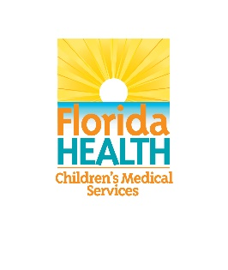
Court Orders Impacting Child Forensic Interviews Meeting Minutes
February 15, 2021
12:00PM – 1:00PM
Microsoft Teams: Click here to join the meeting

ATTENDANCE
Members Present
Subcommittee Chair, Judge Daniel Dawson
Subcommittee Co-Chair, Alan F. Abramowitz
Child Forensic Interview Advisory Committee Chair, Jay Howell
Lorena M. Vollrath-Bueno
Kelly Swartz
Candice Brower
Sub-committee members not present: Terrance Watts, Valerie Stanley
DOH Staff Present
Marceller Hines
S. Nicole Jordan
Guests Present
N/A

Court Orders Impacting Child Forensic Interviews

Welcome:
- Meeting started at 12:02PM
Approval of Minutes from Previous Meeting:
- Subcommittee reviewed and approved minutes from the previous subcommittee meeting conducted on February 1, 2021.
Draft Language of Report:
- Judge Dawson drafted the report and members reviewed the final document which will be submitted to the main CFIAC on February 25, 2021

- The floor was opened to discuss or make any suggestions on verbiage

- Request to fix Connie Jantzen’s name within the document

- List of presentations, highlights, Florida Statutes included into the subcommittee report to the full CFIAC to generate the final report

- 12:07PM the final motion was approved by the subcommittee, which included the approval for DOH staff to make any grammatical changes, to send to the full CFIAC on Thursday, February 25th
- Jay is preparing an introduction and description of the relationship and continuation of the task force itself; then commentary of the mission, then checking to make sure the committee fulfilled the mission as tasked

Next Steps / Next Meeting: The committee may have to reconvene after the main CFIAC meets to review the language submitted
Adjourn: Meeting was adjourned at 12:13PM

