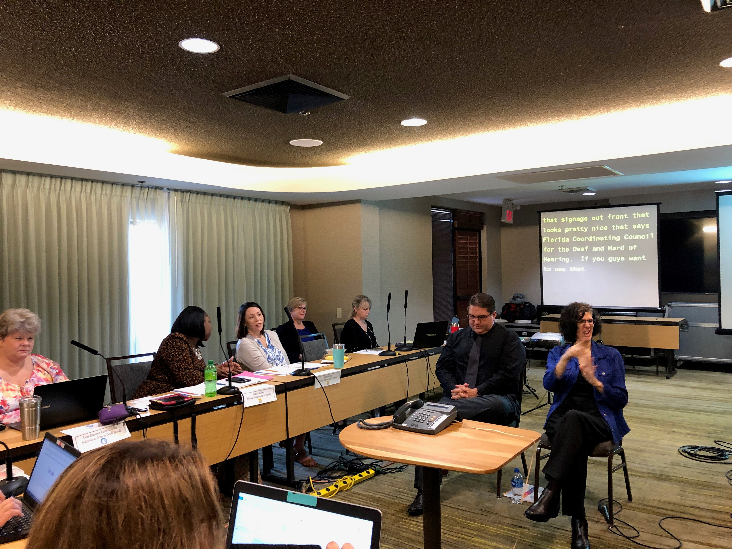  - FCCDHH  Florida Coordinating Council for the Deaf and Hard of Hearing  Quarterly Council Meeting  The Florida Coordinating Council for the Deaf and Hard of Hearing, (FCCDHH) announces a public meeting to which all persons are invited.  GENERAL SUBJECT MATTER TO BE CONSIDERED: The Florida Coordinated Council for the Deaf and Hard of Hearing (FCCDHH) is mandated by Florida Statute 413.271 to serve as an advisory and coordinating body which recommends policies that address the needs of Florida's community who are deaf, hard of hearing, late deafened, or have combined hearing and vision loss.  The purpose of the Quarterly Council Meeting will be to provide Committee updates, deliver presentations by Community Experts, and Public Forum.  A copy of the agenda may be obtained by contacting: Tiffany Baylor at (850)245-4048. | Date and Time: February 6, 2019, 9:00 a.m. – 5:00 p.m.; February 7, 2019, 8:00 a.m. – 12:00 Noon  Location:  Betty Easley Conference Ctr  Southwood State Campus  4075 Esplanade Way  Tallahassee, FL 32399  CART:  Communication Access Real-time Translation Services will be provided remotely via: http://streamtext.net/player?event=FCCDHH  Call-in Number: The meeting may be accessed via Conference Call: 1(888) 299-2873, Conference Room Code: 828-532-954

