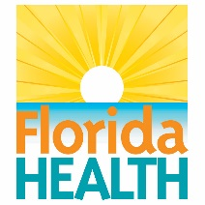
James and Esther King Biomedical Research Grant Symposium
Call for Abstracts Application

Please use this format to complete the abstract to present at the James and Esther King Biomedical Research Program Symposium, which is planned for Thursday, September 19, 2019. Select the type of presentation you prefer:
Oral Presentation Poster Presentation
Complete all fields as your abstract application.

Researcher/Presenter:
Address:
Phone:
Email:
Organization:
Grant Number:
Grant Title:
Research Priority Area: | Select one:  Health disparities Tobacco Use, Prevention, and Treatment  Technology Transfer Feasibility Treatment-Related Morbidities
Abstract Information: Use this box to complete your abstract.

- Abstracts must be submitted by May 8, 2019.
- Abstracts are limited to 500 words.
- Abstracts must include purpose, context, progress to date and impact to Floridians (health outcomes, return on investment). Progress made since the inception of the research project should be included.
- Abstracts must be written at a level targeted to a broad non-scientific audience.
- All abstracts will be compiled and made available to participants.
Logistics:

- All Principal Investigators are strongly encouraged to attend the Symposium. If a Principal Investigator is unable to attend another qualified individual is to be identified to present the paper/poster selected.
- Notification of the presentation format will be made by June 14, 2019 and sent to the Principal Investigator.
Active Grants Only: Use April 2019 Progress Report? Yes No, use provided abstract

Please complete and email to Research@flhealth.gov

