FATAL OPIOID OVERDOSE SURVEILLANCE REPORT
Florida Q1–Q2, 2018

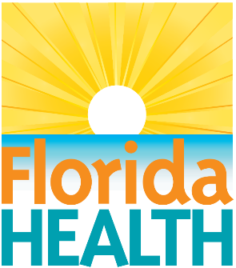
Enhanced State Opioid Overdose Surveillance
FLESOOS.com

Funding Agency:
Centers for Disease Control and Prevention
Grant No. 1 NU17CE924896-01-00

Author:
Jared Jashinsky, PhD
Epidemiologist
Florida Department of Health
Division of Emergency Preparedness and Community Support
Bureau of Emergency Management

Disclaimer:
This product is for reference purposes only and is not to be construed as a legal document. Any reliance on the information contained herein is at the user’s own risk. The Florida Department of Health and its agents assume no responsibility for any use of the information contained herein or any loss resulting therefrom.

EXECUTIVE SUMMARY

BACKGROUND
Opioid overdose rates have increased dramatically since the turn of the century and have continued to rise in recent years. Previous data from the Florida Enhanced State Opioid Overdose Surveillance (FL-ESOOS) project reported 1,121 fatal opioid overdoses for the second half of 2017. The same data showed that men, adults ages 25–34, and whites were most likely to fatally overdose on opioids. Duval, Palm Beach, and Lee counties previously had the highest rates of fatal opioid overdoses. The purpose of this report is to provide current estimates of the number of fatal opioid overdoses in Florida and rates of fatal overdoses across demographic and contextual groups, using data from FL-ESOOS.

METHODS
The number of fatal overdoses and related data were derived from Florida’s vital statistics death records and information provided by Florida medical examiners. Data in this report covered 57 of Florida’s 67 counties, or 82 percent of the population. Rates per 100,000 persons were estimated using data from the 2017 United States (U.S.) Census Bureau, 2013–2017 American Community Survey 5-Year Estimates. The population estimates were limited to counties reporting fatal opioid overdose data to FL-ESOOS, and most analyses were limited to those ages 10 and older. Demographic information including sex, race and ethnicity, age, education, homelessness, and residence in Florida were collected for all decedents. County death rates were calculated using direct age-adjustment to facilitate comparisons.

RESULTS
Analyses suggested these results are reasonably representative of Florida as a whole. Florida experienced 1,224 fatal opioid overdoses in the reporting counties between January and June of 2018, and a fatal opioid overdose rate of 8.3 per 100,000 individuals ages 10 and older. Most fatal overdoses occurred among Florida residents and not those visiting the state. Lee, Volusia, and Palm Beach counties experienced the highest rates of fatal opioid overdoses. Adults ages 35–44 were the most likely age group to experience a fatal opioid overdose. Those with lower education as well as homeless individuals were at greater risk of fatal opioid overdose. Men were 2.4 times more likely than females and whites were 3.4 times more likely than non-whites to experience a fatal opioid overdose.

TABLE OF CONTENTS

BACKGROUND 1
METHODS 2
SAMPLE 2
MEASURES 4
Demographics 4
Overdose Characteristics 4
Fatal Opioid Overdose Rates 5
SAMPLE REPRESENTATIVENESS 5
RESULTS 7
DEMOGRAPHICS 7
OVERDOSE CHARACTERISTICS 8
FATAL OPIOID OVERDOSE RATES 10
DISCUSSION 15
REFERENCES 16

BACKGROUND
Opioid overdose rates have increased dramatically since the turn of the century and have continued to rise in recent years.^{1–3} In 2010, opioid analgesic overdose deaths represented 75 percent of all pharmaceutical overdose deaths. While opioid overdoses have been on the rise in general, overdoses from illegally produced fentanyl and synthetic opioid pain relievers are particularly on the rise.² Opioid abusers accumulate 12 times the health care costs of a similar individual who does not abuse opioids.⁴ The cost to society in the United States (U.S.) from opioid abuse through increased health care, workplace, and criminal justice costs was estimated as $66.5 billion (2019 dollars) in 2007. This number has likely only increased with the increase in opioid abuse in the U.S.
People prescribed higher doses of opioids compared to lower doses for pain management are more likely to experience fatal and non-fatal opioid overdoses.^{5,6} These relationships hold even after controlling for demographic and health factors. Previous data from Florida’s opioid overdose surveillance system reported 1,121 fatal opioid overdoses for the second half of 2017. The same data showed that men, adults ages 25–34, and whites were most likely to fatally overdose on opioids.⁷ Duval, Palm Beach, and Lee counties previously had the highest rates of fatal opioid overdoses.⁷
Naloxone is a medication that can reverse the fatal effects of an overdose, such as failed breathing and loss of consciousness.⁸ Naloxone has been distributed in many states to medical professionals, and even to lay individuals in some states.⁹ Distributing naloxone and training lay people in its use have been found to effectively reduce fatal opioid overdoses and to be cost effective.^{10–12} The World Health Organization and other medical groups recommend expansion of naloxone to lay persons in contact with opioid users and thus in a position to administer during opioid overdoses.^{13,14} Drug users are the laypeople most often given naloxone and, of laypeople, have reversed the most opioid overdoses.¹⁵ Increasing distribution of naloxone in Florida would help reduce the number of fatal opioid overdoses in the state. The Florida Department of Children and Families and the Florida Department of Health are involved in efforts to distribute naloxone for use by first responders and members of the community.
The purpose of this report is to provide current estimates of the number of fatal opioid overdoses in Florida with data from the Florida Enhanced State Opioid Overdose Surveillance (FL-ESOOS) project. Rates of fatal overdoses across various demographic and contextual groups are also presented. Those groups most at risk are identified to characterize the epidemic, as well as highlight those most at need of targeted interventions.

METHODS
The methods of this report are outlined below, including details of the sample, representativeness of data, and measures. The number of fatal overdoses and related data were derived from Florida’s vital statistics death records and information provided by Florida medical examiners for this surveillance project. Florida Department of Health data abstractors were trained in accurate data abstraction methods and follow specific protocols to promote data accuracy and consistent practices. All analyses were conducted in SAS Enterprise 9.4 by a Florida Department of Health epidemiologist.
Data abstracted for FL-ESOOS project must meet the case definition presented in Table 1. Decedents must meet the three criteria to be considered a fatal opioid overdose case: be labeled a drug poisoning death, have an opioid or opiate as a contributing cause of death on the death certificate, and have an opioid or opiate listed as a contributing cause of death on the toxicology report.
Table 1: Case Definition for Fatal Opioid Overdose Meets Three Criteria
Death Certificate ICD-10 CM COD | Death Certificate Contributing COD | Toxicology
X40: Unintentional drug poisoning  X41: Unintentional drug poisoning  X42: Unintentional drug poisoning  X43: Unintentional drug poisoning  X44: Unintentional drug poisoning  Y10: Undetermined intent drug poisoning  Y11: Undetermined intent drug poisoning  Y12: Undetermined intent drug poisoning  Y13: Undetermined intent drug poisoning  Y14: Undetermined intent drug poisoning | T40.0: Poisoning by opium  T40.1: Poisoning by heroin  T40.2: Poisoning by other opioids  T40.3: Poisoning by methadone  T40.4: Poisoning by synthetic narcotics  T40.6: Poisoning by other unspecified narcotics | Substance class: Opioid or opiate

SAMPLE
Data in this report represent 25 Medical Examiner (ME) Districts covering 57 of Florida’s 67 counties, accounting for 82.05 of Florida’s population. A list of all participating ME Districts and their respective counties are in Table 2, and a geographical presentation is in Figure 1. The only counties not to participate were Broward, Citrus, Hernando, Indian River, Lake, Marion, Martin, Okeechobee, St. Lucie, and Sumter counties.
The total population from the included geographic area, used to calculate rates per 100,000 persons, were estimated using data from the 2013–2017 American Community Survey 5-Year Estimates.¹⁶ The 2013-2017 5-year estimate was the most up-to-date population and demographic estimates of county level data in Florida. Though 2013–2017 is not the same population from 2018, it was expected to be sufficiently similar to facilitate these analyses. The estimated population of Florida between 2013 and 2017 was 20,278,447; however, for the purpose of these analyses the population estimates were limited to those counties reporting fatal opioid overdose data to FL-ESOOS. A total of 16,638,076 individuals were estimated to live in Florida’s reporting counties between 2013 and 2017, and 14,791,030 for those ages 10 years and older.

Table 2: Participating Districts and Counties
District | County | 2013–2017 Population
1 | Escambia, Okaloosa, Santa Rosa, and Walton | 737,750
2 | Franklin, Gadsden, Jefferson, Leon, Liberty, Taylor, and Wakulla | 420,046
3 | Columbia, Dixie, Hamilton, Lafayette, Madison, and Suwannee | 170,061
4 | Clay, Duval, Nassau, Columbia and Hamilton | 1,193,769
6 | Pasco and Pinellas | 1,447,978
7 | Volusia | 518,660
8 | Alachua, Baker, Bradford, Gilchrist, Levy, and Union | 386,381
9 | Orange | 1,290,216
10 | Hardee, Highlands, and Polk | 779,759
11 | Miami-Dade | 2,702,602
12 | Desoto, Manatee, and Sarasota | 804,056
13 | Hillsborough | 1,351,087
14 | Bay, Calhoun, Gulf, Holmes, Jackson, and Washington | 303,119
15 | Palm Beach | 1,426,772
16 | Monroe | 76,745
18 | Brevard | 568,183
20 | Collier | 356,774
21 | Glades, Hendry, and Lee | 752,426
22 | Charlotte | 173,236
23 | Flagler, Putnam, St. Johns | 404,028
24 | Seminole | 449,260
25 | Osceola | 325,168

Figure 1: Counties Participating in FL-ESOOS Fatal Opioid Overdose Surveillance
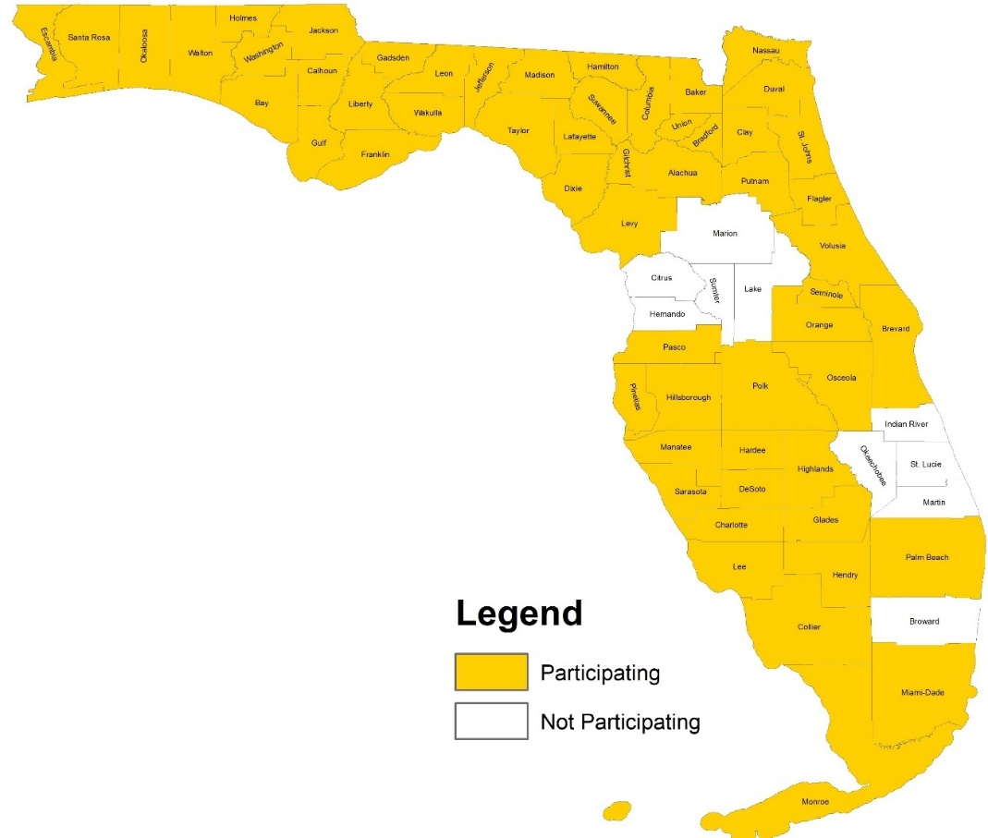

MEASURES
Measures were created for a collection of related variables. Variables can be categorized as the decedent demographics, characteristics of the overdose, and fatal opioid overdose rates. The sections below explain how the measures were created.

Demographics
Demographic information including sex, race and ethnicity, age, education, homelessness, and residence in Florida were collected for all decedents. Frequencies and percentages of decedents for each category were calculated.
Sex was recorded as male or female. Reporting on sexual orientation was considered, but missing data made it not possible. No one was recorded as transgender, but there could have been errors in the data when recording information after death. Racial and ethnic categories were those recommended by the National Institutes of Health.¹⁷ People were categorized as white for persons with origins among any of the original peoples of Europe, North Africa, or the Middle East; black for persons with origins among any of the black racial groups of Africa; Asian for persons with origins among any of the original peoples of the Far East, Southeast Asia, or the Indian subcontinent; American Indian for persons with origins among any of the original people of North America and who maintains cultural identification through tribal affiliation or community recognition (includes Alaska Natives); and Hispanic for persons reporting their ethnicity as Hispanic no matter their reported race. Those with a reported race, but a missing Hispanic status were counted as non-Hispanic. People reporting multiple races were categorized as biracial. Age was originally measured in years but was grouped for this report to match reporting by the Centers for Disease Control and Prevention. All analyses excluded anyone below the age of 10, which during this time period was one child 11 months old, unless stated otherwise.
Education was originally recorded using census categories, but some groups were collapsed to facilitate in reporting. Education was categorized as less than high school, high school graduate, some college, bachelor’s degree, and graduate or professional degree. Yes and no categories were applied to homelessness, military experience, and Florida residence. Recent release from an institution was coded as yes or no for whether an individual had been admitted to or released from one of the following institutions in the month before death: jail, prison, or a detention facility; hospital; psychiatric hospital, other psychiatric institution; long-term residential health facility (e.g., nursing home); supervised residential facility related to alcohol or substance abuse treatment (e.g., residential treatment facility, sober house or group home); and supervised residential facilities not related to alcohol or substance abuse treatment (e.g., halfway houses or work-release homes).

Overdose Characteristics
A measure was created of whether a decedent fatally abused an opiate from a collection of sources. Decedents were coded for whether they had fatally abused an opiate prescribed to themselves, an unprescribed opiate other than heroin (e.g., illicitly obtained or created), heroin, an opiate prescribed to an intimate partner, an opiate prescribed to a family member, a prescribed opiate from another source, or an opiate from an unknown source. Frequencies and percentages of decedents for each category were calculated.
Polysubstance drug abuse was tested for each decedent by checking what other substances were present in the body at the point of death, as measured by toxicology testing. Commonly found substances that are not generally overdose related, such as caffeine and tobacco, were excluded from these analyses. The five most common substances are presented in this report. Frequencies and percentages of decedents for each substance were calculated.
The type of institution was collected for decedents who had recently been released from a treatment or other institution. Institutions included residential facilities not related to substance abuse treatment; jail, prison, or a detention facility; hospital; psychiatric hospital; or other institution. Frequencies and percentages of decedents for each institution were calculated. Lastly, the location of death for each decedent was recorded. Locations included hospital inpatient, emergency department or clinic, decedent’s home, or other location. Counts for each location were calculated, as well as the percent of decedents who died in each location who were administered naloxone.

Fatal Opioid Overdose Rates
Fatal opioid overdose rates were calculated by age range, sex, and county. Population estimates for rates involving age range, sex, and county were limited to individuals ages 10 and older to reflect inclusion of only those overdoses among individuals ages 10 and older. County-level overdose rates were directly age-adjusted to facilitate comparisons across counties without concern for differences in ages across counties.¹⁸
Fatal opioid overdose rates were calculated by education categories. To more accurately represent the education levels instead of age of a community, only individuals ages 25 and older were included as decedents and in population estimates when calculating rates by education. Missing education values for decedents were proportionally added to the other education category frequencies.
Fatal opioid overdose rates were calculated by homelessness status. Population estimates for rates involving homelessness included all ages, but were collected using 2016 data for the geographic areas used in the State of Florida Report: 2016 Homeless Census Estimates produced by the Florida Coalition for the Homeless.¹⁹ Point-in-time (PIT) estimates of homelessness can be converted to annual estimates using a multiplier of 2.5, as conducted in the report.¹⁹ The present analysis used 1.75 as an adjustment of PIT homelessness to create a 6-month homeless variable to match the time frame of this report. The Florida Coalition for the Homeless 2016 report did not have homeless data for Baker, Bradford, Calhoun, DeSoto, Dixie, Franklin, Gadsden, Gilchrist, Glades, Gulf, Holmes, Jefferson, Levy, Liberty, Madison, Nassau, Okeechobee, Taylor, Union, Wakulla, and Washington counties. These counties were removed from the homelessness rates analyses in addition to the counties not included due to not reporting fatal opioid overdose data. Lastly, some data were missing due to FL-ESOOS not having record of the decedent’s homelessness status. Most overdoses occur at home, and identifying addresses would be easier than identifying homelessness, so it is likely that the presence of missing homelessness data for decedents would make a relative risk for fatal opioid overdoses more conservative.

SAMPLE REPRESENTATIVENESS
Demographic differences were assessed between the 57 counties reporting data to FL-ESOOS and the entire state of Florida, or what this report would include if all counties were reporting data. Table 3 presents the demographic breakdowns as well as the differences between the reporting counties and the entire state for sex, race/ethnicity, age, and education. All categories of the reporting counties were within one percent of the entire state of Florida. Though only 82.05 percent of Florida’s population is included in this report, the demographic similarities suggest it is likely the report’s results are generally representative of the state of Florida.

Table 3: Demographic Variables of Reporting Counties and the State of Florida
Variable | % of Reporting Counties |  | % of Florida |  |  | Difference
Sex
Female | 51.06% |  | 51.11% |  | 0.05
Male | 48.94% |  | 48.89% |  | -0.05
Race/Ethnicity
White | 55.38% |  | 55.94% |  | 0.56
Hispanic or Latino | 27.09% |  | 26.49% |  | -0.60
Black or African American | 15.29% |  | 16.12% |  | 0.84
Asian | 2.96% |  | 3.03% |  | 0.07
American Indian or Alaska Native | 0.52% |  | 0.52% |  | 0.00
Age
10–14 | 6.45% |  | 6.43% |  | -0.02
15–24 | 14.11% |  | 13.80% |  | -0.31
25–34 | 14.72% |  | 14.42% |  | -0.30
35–44 | 13.78% |  | 13.66% |  | -0.12
45–54 | 15.27% |  | 15.25% |  | -0.01
55–64 | 14.58% |  | 14.68% |  | 0.10
65–74 | 11.67% |  | 12.02% |  | 0.36
75–84 | 6.61% |  | 6.84% |  | 0.23
Education
Less than high school | 12.75% |  | 12.42% |  | -0.33
High school graduate | 28.90% |  | 28.97% |  | 0.07
Some college | 29.95% |  | 30.16% |  | 0.22
Bachelor’s degree | 18.11% |  | 18.17% |  | 0.06
Graduate or professional degree | 10.29% |  | 10.28% |  | -0.02

RESULTS
The findings of this report are detailed below. Findings are divided into sections for the demographics of decedents, characteristics of the overdoses, and fatal opioid overdose rates.

DEMOGRAPHICS
This section details the demographic breakdowns of all opioid overdose decedents in Florida’s reporting counties between January 1, 2018 and June 30, 2018. Frequency and percentage values for all demographic variables are found in Table 4. For the two biracial individuals, one reported their races as black or African American and white, while the other reported Asian and white. A majority of fatal opioid overdoses were in males, whites, and high school graduates. Most fatal overdoses occurred in Florida residents as opposed to those visiting the state.
Table 4: Demographic Variables
Variable | Frequency |  | Percent
Sex
Female | 375 |  | 30.64%
Male | 849 |  | 69.36%
Race/Ethnicity
White | 980 |  | 80.07%
Hispanic or Latino | 162 |  | 13.24%
Black or African American | 69 |  | 5.64%
Asian | 5 |  | 0.41%
American Indian or Alaska Native | 1 |  | 0.08%
Multiracial | 2 |  | 0.16%
Unknown | 5 |  | 0.41%
Age
10–14 | 0 |  | 0%
15–24 | 80 |  | 6.54%
25–34 | 350 |  | 28.59%
35–44 | 336 |  | 27.45%
45–54 | 258 |  | 21.08%
55–64 | 183 |  | 14.95%
65–74 | 14 |  | 1.14%
75–84 | 3 |  | 0.25%
Education
Less than high school | 211 |  | 17.24%
High school graduate | 574 |  | 46.90%
Some college | 286 |  | 23.37%
Bachelor’s degree | 72 |  | 5.88%
Graduate or professional degree | 27 |  | 2.21%
Unknown | 54 |  | 4.41%
Homelessness
Homeless | 88 |  | 7.19%
Not Homeless | 837 |  | 68.38%
Unknown | 299 |  | 24.43%
Military Experience
Yes | 65 |  | 5.31%
No | 1,108 |  | 90.52%
Unknown | 51 |  | 4.17%
Florida Residence
Resident | 1,121 |  | 91.58%
Non-resident | 81 |  | 6.62%
Unknown | 22 |  | 1.80%

OVERDOSE CHARACTERISTICS
This section details the characteristics of all fatal opioid overdoses in Florida’s reporting areas between January 1, 2018 and June 30, 2018. Characteristics include abuse of own prescription opioid, polysubstance drug abuse, recent release from institution, naloxone administration by location.

About 5 percent of decedents fatally overdosed solely on their own prescription opioid

Frequency and the percent of whether or not, or to whom, the opiate a decedent fatally overdosed on are presented in Table 5. Only 4.5 percent of decedents fatally overdosed solely on an opiate prescribed to themselves. It is likely that some of the unknown prescription types were prescribed to the decedent, but 9 of the 55 decedents who fatally overdosed on their own prescription also overdosed on an illicit opioid. Assuming a similar percentage of the unknown cases exclusively fatally overdosed on their own prescription opioid, 4.96 percent of the sample would have exclusively fatally overdosed on their own prescription opioid. The largest percentage, nearly three-quarters of decedents, used illicit non-prescribed opiate drugs other than heroin.
Table 5: Frequency and percent of decedents Who Fatally Overdosed on an Opiate of Different Prescription Types
Prescription Type | Frequency |  | Percent
Non-prescribed drug, other than heroin | 886 |  | 72.39%
Heroin | 266 |  | 21.73%
Prescribed to decedent | 55 |  | 4.49%
Intimate Partner | 3 |  | 0.25%
Family (non-intimate partner) | 2 |  | 0.16%
Other | 8 |  | 0.65%
Unknown | 390 |  | 31.86%
*Percentages do not add to 100% because decedents could exhibit one or more of fatal overdose prescription types

Polysubstance drug abuse was also frequent among decedents. The five most common substances in the decedents system in addition to opioids at death were alcohol, amphetamines, benzodiazepines, cocaine, and marijuana. In terms of most frequently found, substances such as caffeine and nicotine that are consistently in a sizable portion of the population’s bodies at all times were ignored. The percentage of decedents with the above substances in their bodies can be found in Table 6. Nearly half of decedents used cocaine and opioids while over a third used benzodiazepines and opioids at the time of death. Almost a fifth of the sample, 16.93 percent, used benzodiazepines, cocaine, and opioids at the same time at death. Most decedents, 82.34 percent, had at least one of the above five substances in their body in addition to opioids at the time of death.
Table 6: Percentage of Decedents Exhibiting Polysubstance Drug Abuse with Given Substances
Substance Type | Frequency |  | Percent
Alcohol | 315 |  |  | 25.76%
Amphetamines | 173 |  |  | 14.15%
Benzodiazepines | 448 |  |  | 36.63%
Cocaine | 544 |  |  | 44.48%
Marijuana | 193 |  |  | 15.78%

Data showed that 8.37 percent of decedents were recently released from some institution (e.g., detention facility, hospital, residential facility). Table 7 details the percentage of decedents released from the most common institutions among the 102 decedents who had recently been released.
Table 7: Most Common Institutions from which Decedents were Recently Released
Institution Type | Frequency |  | Percent
Residential facilities not related to substance abuse treatment | 35 |  | 34.31%
Jail, prison, or a detention facility | 30 |  | 29.41%
Hospital | 22 |  | 21.57%
Psychiatric hospital | 4 |  | 3.92%
Other institution | 4 |  | 3.92%

After the overdose, decedents were most likely to have died in their own home, at an emergency department or outpatient facility, or at a hospital. Naloxone was administered to 13.81 percent of all decedents. These deaths could stem from cases where the drug was administered too late, multiple drugs were in their system, or an insufficient dose was given. Table 8 shows the percent of naloxone administration by most common location of death.
Table 8: Percent of Naloxone Administration by Most Common Locations of Death
Death Location | Total Decedents |  | Naloxone Administered
Hospital inpatient | 89 |  | 37.08%
ED/Outpatient | 210 |  | 41.90%
Decedent’s home | 562 |  | 4.98%
Other | 357 |  | 5.60%
*Excludes two in hospital inpatient with missing administration values, two at home with missing administration values, and two missing locations where naloxone was not administered

FATAL OPIOID OVERDOSE RATES
Florida experienced 1,224 fatal opioid overdoses in the reporting counties between January and June of 2018. A total of 8.28 per 100,000 individuals ages 10 and older died of opioid overdoses during these six months. This section shares fatal opioid overdose count and rates by categories of interest: county, sex, age, education, race/ethnicity, and homelessness.

1,224 fatal opioid overdoses in Florida’s reporting counties between January and June of 2018

Age-adjusted fatal opioid overdose rates in all reporting Florida counties can be found in Table 9 and Figure 2. Twelve counties experienced an age-adjusted fatal opioid overdose rate greater than 10 per 100,000. In descending order, they were Lee, Volusia, Palm Beach, Duval, Putnam, Brevard, Madison, Osceola, Clay, Seminole, Orange, and Levy counties. Fatal opioid overdose rates in counties with low overall counts should be interpreted cautiously as they can drastically change due to small amounts of error or underreporting.
Fatal opioid overdose rates by age ranges among people ages 10 and older are presented in Figure 3. During these months, people ages 35–44 had the highest death rate of 14.18 deaths per 100,000. Narrowing in more specifically, people ages 35–40 had the highest death rate with 17.53 deaths per 100,000.
Fatal opioid overdose rates for males and females ages 10 and older are presented in Figure 4. During these months, men and women had 11.79 and 4.94 fatal opioid overdoses respectively per 100,000. Men were 2.4 times more likely than women to fatally overdose on opioids.
Fatal opioid overdose rates by education groups among people ages 25 and older are presented in Figure 5. High school graduates were the most at-risk for fatal opioid overdose with 16.64 deaths per 100,000 people ages 25 and older over the six months. A dose response was observed with more education being related to less risk of fatal opioid overdose. The only exception was those with less than a high school degree were less likely to fatally overdose than those with a high school degree. It is possible that this anomaly is due to more older individuals not having graduated from high school, with older age being related to lower opioid overdose risk.
Fatal opioid overdose rates by race and ethnicity among people of all ages are presented in Figure 6. Whites were the most at risk of fatal opioid overdose with 10.64 deaths per 100,000 individuals over the six months. Whites were 3.4 times more likely than all other race and ethnicities to experience a fatal opioid overdose.
A very small percentage of Florida residents are estimated to be homeless. It is estimated that 0.31 percent of Florida residents were homeless in the first six months of 2016, or 47,887 individuals. However, this group has a much larger risk of fatal opioid overdose. Homeless individuals were 34.42 times more likely to experience a fatal opioid overdose compared to non-homeless individuals. This estimate is sensitive to missing values given the small number of homeless individuals; however, it is likely safe to say that homeless individuals are over 10 times more likely to fatally overdose on opioids than non-homeless individuals.

Table 9: Fatal Opioid Overdose Rates Per 100,000 People Ages 10+ by County
County | Count |  | Raw | Age-Adjusted |  |  | County | Count |  | Raw |  | Age-Adjusted
Alachua | 6 |  | 2.58 |  | 2.56 |  | Lee | 102 |  | 16.16 |  | 18.70
Baker | 0 |  | 0.00 |  | 0.00 |  | Leon | 7 |  | 2.73 |  | 2.94
Bay | 6 |  | 3.80 |  | 3.72 |  | Levy | 3 |  | 8.52 |  | 10.43
Bradford | 0 |  | 0.00 |  | 0.00 |  | Liberty | 0 |  | 0.00 |  | 0.00
Brevard | 63 |  | 12.27 |  | 13.19 |  | Madison | 2 |  | 12.16 |  | 12.42
Broward | – |  | – |  | – |  | Manatee | 25 |  | 7.68 |  | 8.64
Calhoun | 0 |  | 0.00 |  | 0.00 |  | Marion | – |  | – |  | –
Charlotte | 2 |  | 1.23 |  | 1.07 |  | Martin | – |  | – |  | –
Citrus | – |  | – |  | – |  | Miami-Dade | 95 |  | 3.96 |  | 3.71
Clay | 22 |  | 12.37 |  | 12.13 |  | Monroe | 4 |  | 5.70 |  | 5.53
Collier | 21 |  | 6.50 |  | 7.80 |  | Nassau | 5 |  | 7.13 |  | 7.10
Columbia | 5 |  | 8.34 |  | 8.14 |  | Okaloosa | 11 |  | 6.39 |  | 6.08
DeSoto | 0 |  | 0.00 |  | 0.00 |  | Okeechobee | – |  | – |  | –
Dixie | 0 |  | 0.00 |  | 0.00 |  | Orange | 137 |  | 12.12 |  | 10.88
Duval | 126 |  | 15.90 |  | 14.71 |  | Osceola | 37 |  | 13.10 |  | 12.18
Escambia | 12 |  | 4.39 |  | 4.13 |  | Palm Beach | 183 |  | 14.34 |  | 15.45
Flagler | 2 |  | 2.09 |  | 2.49 |  | Pasco | 33 |  | 7.43 |  | 7.87
Franklin | 0 |  | 0.00 |  | 0.00 |  | Pinellas | 55 |  | 6.37 |  | 6.67
Gadsden | 0 |  | 0.00 |  | 0.00 |  | Polk | 7 |  | 1.22 |  | 1.27
Gilchrist | 0 |  | 0.00 |  | 0.00 |  | Putnam | 8 |  | 12.48 |  | 14.00
Glades | 0 |  | 0.00 |  | 0.00 |  | Santa Rosa | 3 |  | 2.04 |  | 1.96
Gulf | 0 |  | 0.00 |  | 0.00 |  | Sarasota | 16 |  | 4.28 |  | 5.80
Hamilton | 0 |  | 0.00 |  | 0.00 |  | Seminole | 47 |  | 11.79 |  | 10.89
Hardee | 0 |  | 0.00 |  | 0.00 |  | St. Johns | 8 |  | 3.97 |  | 4.73
Hendry | 3 |  | 8.94 |  | 8.54 |  | St. Lucie | – |  | – |  | –
Hernando | – |  | – |  | – |  | Sumter | – |  | – |  | –
Highlands | 1 |  | 1.10 |  | 1.42 |  | Suwannee | 0 |  | 0.00 |  | 0.00
Hillsborough | 90 |  | 7.64 |  | 7.10 |  | Taylor | 0 |  | 0.00 |  | 0.00
Holmes | 1 |  | 5.78 |  | 5.64 |  | Union | 1 |  | 7.33 |  | 6.11
Indian River | – |  | – |  | – |  | Volusia | 72 |  | 15.38 |  | 16.77
Jackson | 2 |  | 4.56 |  | 4.56 |  | Wakulla | 0 |  | 0.00 |  | 0.00
Jefferson | 0 |  | 0.00 |  | 0.00 |  | Walton | 1 |  | 1.77 |  | 1.53
Lafayette | 0 |  | 0.00 |  | 0.00 |  | Washington | 0 |  | 0.00 |  | 0.00
Lake | – |  | – |  | –
‘–‘ signifies no data reported by county

Figure 2: Age-Adjusted Fatal Opioid Overdose Rates per 100,000 People Ages 10+ by County
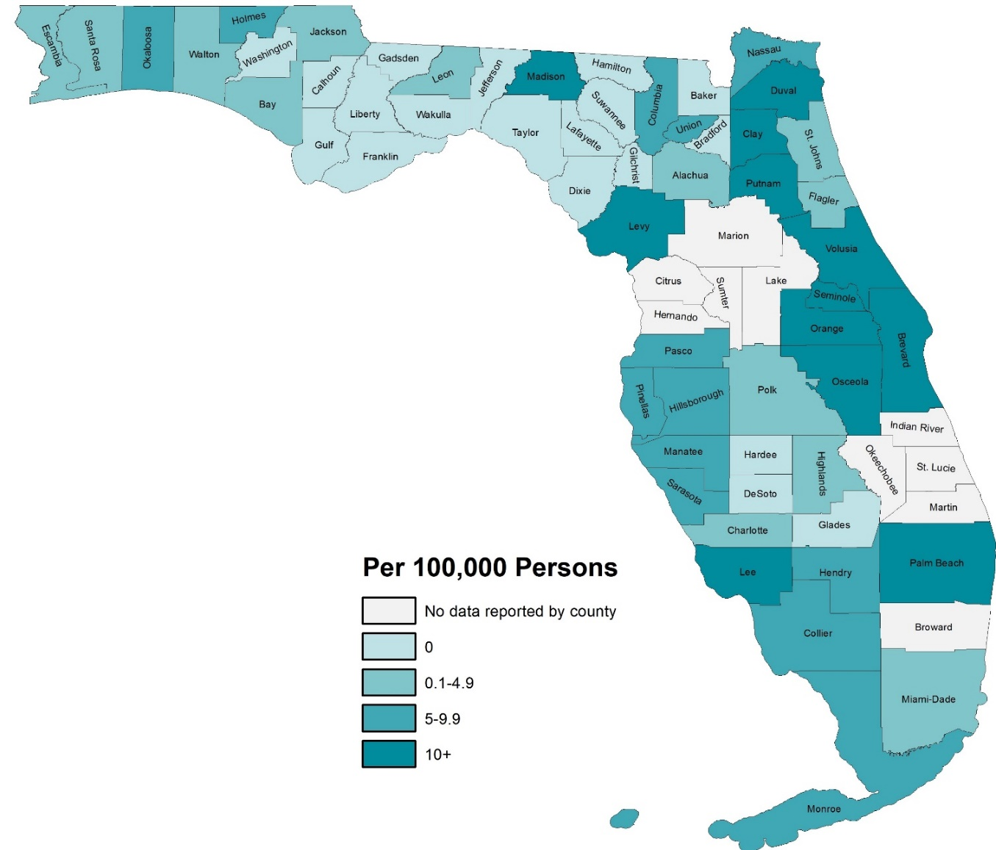

Figure 3: Fatal Opioid Overdose Rate by Age in Years; People Ages 10+; Florida’s Reporting Counties; January–June 2018

Figure 4: Fatal Opioid Overdose Rate by Sex; People Ages 10+; Florida’s Reporting Counties; January–June 2018

Figure 5: Fatal Opioid Overdose Rate by Education; Adults 25+; Florida’s Reporting Counties; January–June 2018

Figure 6: Fatal Opioid Overdose Rate by Racial/Ethnic Groups; All Ages; Florida’s Reporting Counties; January–June 2018

DISCUSSION
Though not all Florida’s population is included in this report, the demographic similarities of the sample suggested it is likely the report’s results are generally representative of the state of Florida. The section below identifies the most salient points of the report and discusses areas of particular opportunity for the state.
Florida experienced 1,224 fatal opioid overdoses in the reporting counties between January and June of 2018. Florida experienced 8.3 deaths per 100,000 individuals ages 10 and older during these months. If a similar rate of fatal opioid overdoses happened in the second half of 2018, the 16.6 overdoses per 100,000 would be comparable to the national average.²⁰ Though Florida does not have as large of a problem per population as many states, Florida as the third most populous state in the U.S. represents a large proportion of the opioid epidemic in the U.S.
The most affected counties in Florida experienced significant age-adjusted fatal opioid overdose rates. If the rates maintained through the end of 2018, Lee, Duval, Volusia, and Palm Beach counties would have respectively experienced raw annual fatal opioid overdose rates of 32.3, 31.8, 30.8, and 28.7 per 100,000 people ages 10 and older. These county rates are similar to some of the top states most affected by the opioid epidemic (e.g., Maryland at fifth, Massachusetts at seventh).²⁰ These counties were similarly ranked at the end of 2017 with Duval at first, Palm Beach at second, Lee at third, and Volusia at fifth.⁷
Resources should be targeted toward individuals most at-risk, namely young to middle aged adults, men, whites, the homeless, and those with lower education. These findings are similar to previous reporting in the state that men, whites, and those with lower education were at greater risk of fatal opioid overdose.⁷ As public health resources are often limited, it is imperative to make the largest impacts possible in these groups most at-risk.
Decedents overdosed on a prescription opioid prescribed to themselves in approximately 5 percent of cases. Careful prescribing and education to those prescribed opioids might have helped for a small portion of the deceased individuals, but the much larger problem is in the illicit manufacturing and distribution of opioids. More could be done to prevent people from accessing other’s prescriptions and combating illicit forms of opioids.
Naloxone was not administered in almost all cases where deaths occurred outside medical settings (e.g., decedent’s home). Many areas have successfully distributed naloxone to laypersons to combat fatal opioid overdoses in settings where medical professionals are not present.^{9–12} Though better, naloxone was administered in less than half of cases where deaths occurred in medical settings (i.e., hospital, emergency department, outpatient). More work should be done in the state to distribute naloxone to both medical professionals and laypersons alike. Naloxone is highly effective at rapidly reversing the effects of an opioid overdose, presents minimal risks, and is cost-effective.^{8,11}
Florida Department of Health implements the Helping Emergency Responders Obtain Support (HEROS) Program where Florida agencies who employ emergency responders and agree to report naloxone administrations through approved systems, can receive free naloxone. Eligible applicants can visit http://www.floridahealth.gov/licensing-and-regulation/ems-system/heros.html to learn more and enroll in the program.

REFERENCES
1. Volkow ND, Frieden TR, Hyde PS, Cha SS. Medication-Assisted Therapies — Tackling the Opioid-Overdose Epidemic. N Engl J Med. 2014;370(22):2063-2066. doi:10.1056/nejmp1402780.
2. Rudd RA, Aleshire N, Zibbell JE, Gladden RM. Increases in Drug and Opioid Overdose Deaths—United States, 2000–2014. Morb Mortal Wkly Rep. 2016;64(50):1378-1382. doi:10.1111/ajt.13776.
3. Rudd RA, Seth P, David F, Scholl L. Increases in Drug and Opioid-Involved Overdose Deaths — United States, 2010–2015. Morb Mortal Wkly Rep. 2016;65(50-51):1445-1452. doi:10.2105/AJPH.2014.302367?journalCode=ajph.
4. White AG, Birnbaum HG, Mareva MN, et al. Direct Costs of Opioid Abuse in an Insured Population in the United States. J Manag Care Pharm. 2005;11(6):469-479.
5. Dunn KM, Saunders KW, Rutter CM, et al. Overdose and prescribed opioids: Associations among chronic non-cancer pain patients. Ann Intern Med. 2010;152(2):85-92. doi:10.1059/0003-4819-152-2-201001190-00006.
6. Bohnert AS, Valenstein M, Bair MJ, et al. Association Between Opioid Prescribing Patterns and Opioid Overdose-Related Deaths. J Am Med Assoc. 2011;305(13):1315-1321.
7. Florida Department of Health. Fatal Opioid Overdose Surveillance: Florida 2017 Q3-Q4. Tallahassee, FL; 2017. http://www.floridahealth.gov/statistics-and-data/fl-esoos/reports.html.
8. Centers for Disease Control and Prevention (CDC). Using Naloxone to Reverse Opioid Overdose in the Workplace: Information for Employers and Workers.; 2018. doi:https://doi.org/10.26616/NIOSHPUB2019101.
9. Wheeler E, Davidson PJ, Jones TS, Irwin KS. Community-Based Opioid Overdose Prevention Programs Providing Naloxone — United States, 2010 Drug Overdose Prevention and Education (DOPE) Project, Harm Reduction Coalition, Oakland. MMWR Morb Mortal Wkly Rep. 2012;61(6):101-105.
10. Walley AY, Xuan Z, Hackman HH, et al. Opioid overdose rates and implementation of overdose education and nasal naloxone distribution in Massachusetts: Interrupted time series analysis. BMJ. 2013;346(f174):1-13. doi:10.1136/bmj.f174.
11. Coffin PO, Sullivan SD. Cost-Effectiveness of Distributing Naloxone to Heroin Users for Lay Overdose Reversal. Ann Intern Med. 2013;158(1):1-9. doi:10.3111/13696998.2013.811080.
12. Clark AK, Wilder CM, Winstanley EL. A Systematic Review of Community Opioid Overdose Prevention and Naloxone Distribution Programs. J Addict Med. 2014;8(3):153-163. doi:10.1097/ADM.0000000000000034.
13. Doyon S, Aks SE, Schaeffer S. Expanding Access to Naloxone in the United States. J Med Toxicol. 2014;10(4):431-434. doi:10.3109/15563650.2014.968657.
14. World Health Organization. Community Management of Opioid Overdose. Geneva, Switzerland; 2014. doi:10.4324/9781315775425.
15. Wheeler E, Jones TS, Gilbert MK, Davidson PJ. Opioid Overdose Prevention Programs Providing Naloxone to Laypersons — United States, 2014. Morb Mortal Wkly Rep. 2015;64(23):631-635. http://www.ncbi.nlm.nih.gov/pubmed/26086633%0Ahttp://www.pubmedcentral.nih.gov/articlerender.fcgi?artid=PMC4584734.
16. U.S. Census Bureau. Understanding and Using ACS Single-Year and Multiyear Estimates.; 2018. https://www.census.gov/content/dam/Census/library/publications/2018/acs/acs_general_handbook_2018_ch03.pdf.
17. National Institutes of Health. Racial and Ethnic Categories and Definitions for NIH Diversity Programs and for Other Reporting Purposes. NOT-OD-15-089. https://grants.nih.gov/grants/guide/notice-files/NOT-OD-15-089.html. Published 2015. Accessed August 13, 2019.
18. Buescher PA. Statistical Primer: Age-Adjusted Death Rates. Raleigh, NC; 2010. https://schs.dph.ncdhhs.gov/schs/pdf/primer13_2.pdf.
19. Ullman MD. State of Florida Report: 2016 Homeless Census Estimates and Funding Need to End Chronic Homelessness.; 2016. http://www.nhipdata.org/local/upload/file/Florida Homeless Report 2016 09_30_16 - final report.pdf.
20. Kaiser Family Foundation. Opioid Overdose Death Rates and All Drug Overdose Death Rates Per 100,000 Population (Age-Adjusted). State Health Facts. https://www.kff.org/other/state-indicator/opioid-overdose-death-rates/?currentTimeframe=0&sortModel=%7B%22colId%22:%22Location%22,%22sort%22:%22asc%22%7D. Published 217AD. Accessed August 19, 2019.

