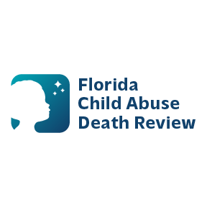 **AGENDA**

**Circuit 15 Local Child Abuse Death Review Meeting**

December 18, 2025

Meeting Time: 9:00 AM – 9:15 AM

Meeting location:

Florida Department of Health  
800 Clematis Street, Room 2200  
West Palm Beach, FL 33401

* Welcome and Introductions
* Local CADR Business
* CADR Program Updates
* Other Business
* Adjourn