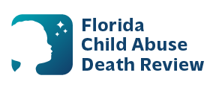
AGENDA
Circuit 13 Local Child Abuse Death Review Meeting
December 10, 2025 1:00 PM-1:15 PM
Teams Meeting:
Meeting ID: 269 407 375 014 41
Passcode: ni6Dt3Yz

- Welcome and Introductions
- Local CADR Business
- CADR Program Updates
- Other Business
- Adjourn

