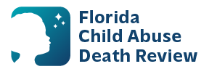
AGENDA
State Child Abuse Death Review Committee Meeting
Microsoft Teams Meeting
Meeting ID: 297 785 063 900 8
Passcode: ZE6gz28S
Thursday, December 11, 2025
9:00am – 12:00pm ET

- Welcome and Introductions
- Review of Previous Meeting Minutes
- CADR Data & Case Review Updates
- Water Safety
- CADR Program Updates
- Other Business
- Adjourn

