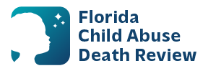
AGENDA
State Child Abuse Death Review Committee Meeting
Microsoft Teams Meeting
Meeting ID: 240 486 042 166 54
Passcode: S2Te29Dk
Second Thursday of each month

- Welcome and Introductions
- Review of Previous Meeting Minutes
- CADR Data & Case Review Updates
- Water Safety
- CADR Program Updates
- Other Business
- Adjourn

