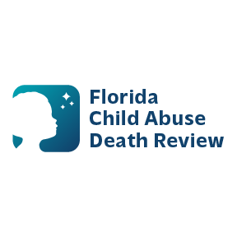 **AGENDA**

**Circuit 13 Local Child Abuse Death Review Meeting**

* Welcome and Introductions
* Local CADR Business
* CADR Program Updates
* Other Business
* Adjourn