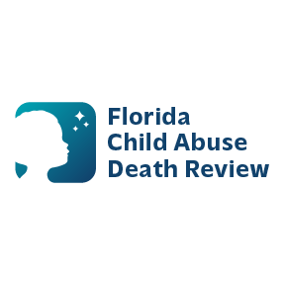 **AGENDA**

**Circuit 13 Local Child Abuse Death Review Meeting**

August 13, 2025 1:00 PM-1:15 PM

Teams Meeting:

Meeting ID: 262 711 604 116

Passcode: nV7xc2Re

* Welcome and Introductions
* Local CADR Business
* CADR Program Updates
* Other Business
* Adjourn