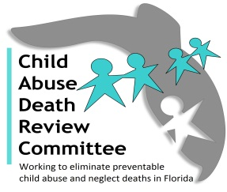
AGENDA
Local Child Abuse Death Review Leadership Meeting
Microsoft Teams Meeting
Meeting ID: 256 469 099 932
Passcode: sB8UyM
November 12, 2025
10:00 AM-11:30 AM

- Welcome and Introductions
- CADR Case Review Updates and Priorities
- Local CADR Business
- CADR Program Updates
- Open Discussion
- Adjourn

