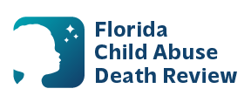
AGENDA
Circuit 13 Local Child Abuse Death Review Meeting
November 12, 2025 1:00 PM-1:15 PM
Teams Meeting:
Meeting ID: 264 507 485 348 9
Passcode: Sx9Li7pV

- Welcome and Introductions
- Local CADR Business
- CADR Program Updates
- Other Business
- Adjourn

