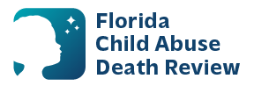
AGENDA
State Child Abuse Death Review Committee Meeting
Microsoft Teams Meeting
Meeting ID: 287 453 637 594 0
Passcode: Zc7uc3nZ
November 13, 2025
9:00 AM-12:00 PM ET

- Welcome and Introductions
- Review of Previous Meeting Minutes
- CADR Data & Case Review Updates
- CADR Program Updates
- Other Business
- Adjourn

