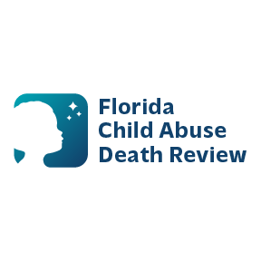 **AGENDA**

**Circuit 9 Local Child Abuse Death Review Meeting**

**Meeting Date: July 25, 2025**

**Meeting Place: District Nine Medical Examiner's Office  
2350 E. Michigan Street  
Orlando, Florida 32806**

* Welcome and Introductions
* Local CADR Business
* CADR Program Updates
* Other Business
* Adjourn