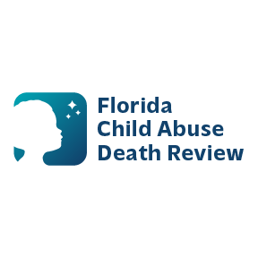 **AGENDA**

**Circuit 13 Local Child Abuse Death Review Meeting**

September 10, 2025 1:00 PM-1:15 PM

Teams Meeting:

Meeting ID: 249 510 304 860 3  
Passcode: As63K29C

* Welcome and Introductions
* Local CADR Business
* CADR Program Updates
* Other Business
* Adjourn