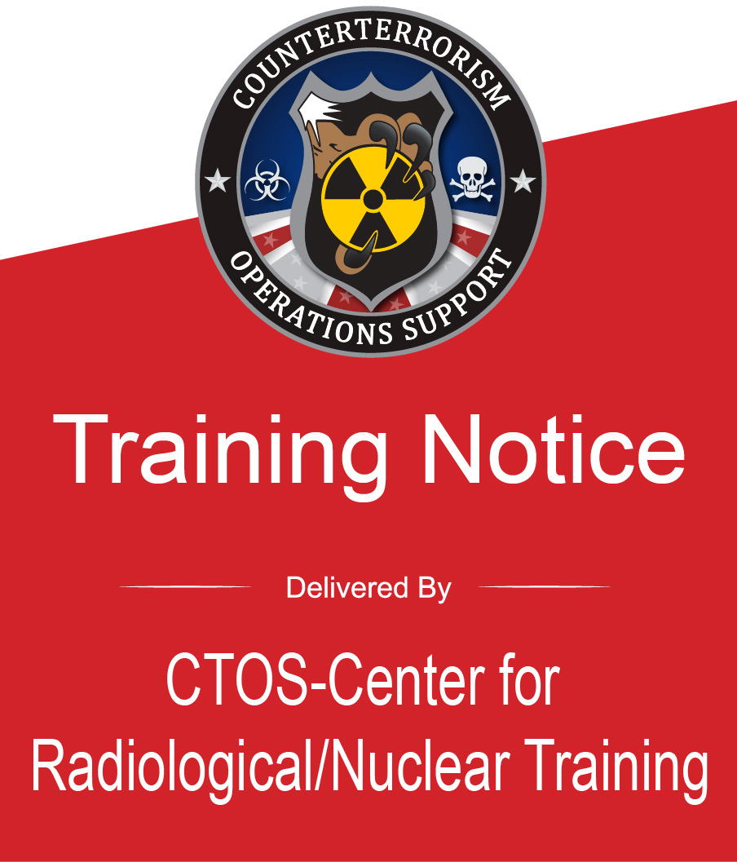 | PER-388, Radiological Operations Support Specialist (ROSS)  Hosted By: Florida Department of Health Bureau of Radiation Control  Location: 2100 All Children’s Way, Orlando, FL 32818  Hours: 8:00am – 4:00pm each day  Dates: Tuesday–Friday, September 30 – October 3, 2025  Course Length: 32 hrs. (28 contact hrs.)  Required Prerequisites: Web-based courses  - Radiological Dispersal Device (RDD)  Response Guidance: Planning for the First100 Minutes (AWR-400-W)  - Introduction to Nuclear Detonation Effects and Response Strategies (PER-307-W)
Course Description:
PER-388 trains radiological specialists to become candidates for the position of Radiological Operations Support Specialist (ROSS). A ROSS is a state and local Subject Matter Expert tasked with identifying and providing critical information pertaining to radiological/nuclear incidents to Responders, Key Leaders, and Decision Makers in an Incident Command System environment. The ROSS will assist the Incident Commander and Key Leaders by making the technical aspects of a coordinated
response clear and understandable to all state and local stakeholders.
REGISTER TODAY!
- Navigate to the Acadis Homepage https://ctos.acadisonline.com/  - Select the WebForms link.  - Select New User Account Request. Complete all fields including Applicant Certification.  Note: To receive credit for this FEMA course, attendees must list a Student Identification (SID) Number on the Account Request. A SID number can be obtained at the following link: https://cdp.dhs.gov/femasid  - Select Submit on the bottom of the page.  You will receive an email within 48 hours with your new LMS account information and a request to set up a password.  Once your account is active return to the Acadis Homepage page and sign in.  From the Home Page, click on the Training and Events-Browse or Sign up for Training tab. Select your class and follow the LMS prompts. |  | 