This attachment is offered to provide a better understanding of the current environment and the current application (called EHD, or Environmental Health Database) that the Department is seeking to replace through this ITN. To do so, it is best to understand the program areas within the Bureau of Environmental Health that the application serves.

Program Areas

Environmental Health programs are defined in Florida Administrative Code Chapter 64E, and described below.

- Biomedical Waste (BMW) – Pursuant to Florida Administrative Code Rule 64E-16 and section 381.0098, Florida Statutes, this program minimizes the risk from potentially infectious medical waste to health care workers, treatment personnel, transporters and the public by propagating minimum sanitary practices related to the management of biomedical waste and assuring these practices are maintained. The program works with facilities that generate, transport, store or treat biomedical waste from primates or other animals and monitors the treatment and disposal of biomedical waste to ensure the waste is properly handled to protect public health. The program maintains a set of regulations for generators, transporters, and disposal facilities with distinct inspection forms for each. In addition to inspections, program activities include complaint investigations and re-inspections. All facilities are billed annually. There are many small generators who are exempt from fees but still need to be permitted. These inspection forms are available for remote devices.

- Body Piercing (BP) – Pursuant to section 381.0075, Florida Statutes, this program regulates establishments to reduce the occurrence of infection of the pierced site as well as the incidence of transmission of bloodborne pathogens. The facilities which provide piercing services are regulated and inspected. Body-piercing facilities may be permanent store-fronts or a temporary booth or exhibit. Both must meet the sanitary standards to receive a permit and conduct business. Regular inspections are required and permits are issued for complying businesses. In addition, activities include review of injury reports, complaint investigations and re-inspections. This inspection form is available for remote devices.

- Food Hygiene (FH) – Pursuant to Florida Administrative Code Rule 64E-11, this program ensures that food establishments regulated by the Department are operated in accordance with applicable regulations and in a safe and sanitary manner to minimize the occurrence of food-related illness. Assures that food does not contain any added poisonous or added deleterious substances, is not part of a diseased, contaminated, or decomposed substance and that food has been produced, prepared, packed and held under sanitary conditions. This program covers institutional food services such as those provided by adult care facilities, jails, prisons and detention centers, mental health facilities, hospitals, civic and fraternal organizations, movie theaters, bars and lounges, domestic violence centers, schools, colleges, and universities. It also covers temporary events, mobile food units, and vending machines. It also includes limited food service for commercial establishments such as movie theaters and bars. This program does not inspect or regulate commercial food restaurants. CHD inspectors perform regular inspections and issue licenses for entities meeting the sanitary standards.

Regular inspections ensure that establishments are properly designed, built, equipped and maintained. Inspectors ensure they use a safe water supply and wastewater disposal system, approved food sources, and the maintenance of safe food temperatures. Inspections are used to educate establishment management and staff. In addition to inspections, CHDs conduct thorough plan reviews for new construction or remodeling, conduct and assist in epidemiological investigations of suspected food-related illnesses and compliance with the Food Safety and Sanitation Program.

- Group Care (GC)– Pursuant to Florida Administrative Code Rule 64E-12, this program ensures compliance with applicable environmental health laws and rules by conducting inspections, providing public education, performing epidemiological investigations and complaint investigations in the program areas. Prescribes sanitary practices relating to the construction, operation and maintenance of community-based residential as well as public and private schools. The program does not permit or license many of the entities they inspect. It provides inspections and supplies inspection results to the state agency that does produce the licensing. For example, foster homes and child caring agencies are inspected at the request of the Department of Children and Families (DCF) and results are sent to DCF. Permits are not typically issued for group care facilities. This inspection form is available for remote devices.

- Limited Use Water (LUW) – Pursuant to Florida Administrative Code Rule 64E-8, this program refers to private, multifamily, and limited use public water systems (LUPWS) that make water available to the public. LUPWS serve a limited number of residences or a business that operates for a limited number of days or provides no water consumption to a transient population. This program sets standards for well construction, conducts sanitary surveys, plan reviews, evaluates water treatment and distribution systems, collects and evaluates water samples and investigates waterborne disease outbreaks. Samples are sent to the state laboratory for analysis with results shared with the Department of Environmental Protection. It performs regular inspections and invoices annually. The program permits well construction, repair and abandonment. An official letter of clearance is issued when all sample analysis warrants. Permits are issued for all wells to assure each well has a tracking number that is not changed when ownership of the property changes. Inspections are conducted once a year. This inspection form is available for remote devices.

- Migrant Farmworker Housing (MFH) – Pursuant to Florida Administrative Code Rule 64E-14, this program was called “Migrant Labor Camps” until recently. The objective of this program is to reduce the risk of communicable disease transmission and injury among migrant farm workers by establishing comprehensive and uniform procedures for permitting and inspecting migrant housing. DOH staff perform plan reviews, permitting, regularly scheduled inspections, investigations, education, and assure application of state laws and rules. Permits are issued and owners are invoiced annually. This inspection form is available for remote devices.

- Miscellaneous Programs – This program area tracks the entities, inspections and financial transaction for programs contracted with a county government and that is not supported statewide. Each county may require different inspections and fees for a program so each must be customized to the individual counties that support that program. The types of entities in this area vary by county as well. Inspection forms have not been added to the remote application.

- Mobile Home Parks (MHP) – Pursuant to Florida Administrative Code Rule 64E-15, this program operates with mobile home, recreational vehicle, lodging parks, and recreational camps. Issues covered by this program include water supply, sewage disposal, sanitary facilities, plumbing, garbage and refuse disposal, and insect and rodent controls. The program protects the public from the hazard of untreated sewage and the likelihood of disease transmission from unapproved water sources. Other actions include construction plan reviews, visiting construction sites, taking water samples, and educating park and camp operators and the public on the reason for the program standards. Water sample results are maintained within EHD. Permits are issued annually. Inspections and construction plans are maintained within EHD. This inspection form is available for remote devices.

- Nuisance Complaint Investigations – Pursuant to Florida Statute 386, it is the duty of the Florida Department of Health to investigate and, working with the appropriate parties, remove or abate any action or existing issue that may cause, directly or indirectly, disease or injury to the health or life of individuals. Inspectors record reported issues and the circumstances found during the investigation. The system creates many letters and legal notices to be delivered to the person or company responsible for the issue defining legal definitions, required remediation and timeframes. Inspectors track the communications with the responsible parties which the system maintains as historical record. Nuisance complaints may or may not be connected to a permitted entity but must be maintained by the system from first report to removal or abatement of the nuisance conditions. The nuisance complaint form needs to be added to the remote application.

- Onsite Sewage Treatment and Disposal Systems (OSTDS) – Pursuant to Florida Administrative Code Rule 64E-16, this program monitors three separate areas with different standards, inspection frequencies and sampling requirements. Program activities include licensing of septic tank contractors and businesses, approval of treatment receptacle designs, evaluation of aerobic treatment units, approval of innovative products, approval of alternative drainfield products and additives, reviewing construction permit applications for performance-based treatment systems, conducting onsite sewage system research, providing training and technical support, and conducting county health department programmatic evaluations.

- The construction component governs the planning, building, repairs, maintenance, and modifications for septic tanks and drain fields. Inspectors visit the sites as needed to review plans, evaluate the site, approve building materials, and inspect completed systems. The program conducts complaint investigations, sanitary surveys, and enforcement actions as needed. Owners or contractors wishing to build a new system or modify an existing system apply using the appropriate application form along with a site plan and receive permission before proceeding. Permits are issued for construction and for final authorization. Invoices are created as needed throughout the process and there is no annual billing. When a location switches from septic tank to sanitary sewers, an inspection may be performed with laboratory sampling to confirm the abandonment. All abandoned systems are reported to the Department and tracked for future planning.

- The operating component of OSTDS performs regular inspections on working systems to assure they are meeting operating standards. Inspections are planned, invoices are produced annually, and permits are issued for systems that meet the standards. These inspections require submission of bacteriological and chemical samples to the state labs. EHD maintains a history of these sample results. Operating systems are used in commercial settings where multiple businesses send waste to the same septic system. In these situations, each business accessing the tank must submit an annual survey documenting number of users, business type, and other information that allows the inspector to confirm the system is operating within its limits. Operating systems are required to contract with a service provider to maintain aerobic treatment units (ATUs) and performance-based systems (PBs) to assure these systems are working at their maximum efficiency. Permits are issued for the operating systems.

- The service component of OSTDS tracks and maintains service providers who clean and repair septic systems, build and install septic tanks, or provide temporary waste collection and disposal. Any business resource that is used storing, transporting or disposing of waste is tracked within EHD. These range from temporary privies to septic tanks to tank trucks to incinerators and landfills. All services must be provided by currently licensed contractors who are listed within EHD. Inspectors assure the resources are functional and appropriate for the work being performed. Maintenance entities that provide services to ATU and PB systems must report inspections and work performed on these systems to the county health departments on a quarterly basis through a public portal. Inspections performed by CHD inspectors are maintained within EHD.

- Rabies – Pursuant to Florida Administrative Code Rule 64d-3. CHDs collect human exposure and animal surveillance data by conducting investigations into animal bite incidents. The data is shared with relevant organizations to determine if any occurrence of rabies is naturally occurring or a possible bioterrorist event. Data collected in the investigations and actions taken to notify affected people, witnesses and agencies is managed within EHD.

- Swimming Pools – Pursuant to Florida Administrative Code Rule 64E-9, this program approves and inspects public pools (any pool that is not defined as private), public bathing places, spas and recreational water attractions to assure none are at risk of providing a health nuisance. Inspections verify water quality, use of chemicals, cleanliness, pool circulation systems, and water levels meet the established standards for operation. The program charts violations, investigates complaints and initiates enforcement actions when necessary. Laboratory samples are taken with results recorded in EHD. Variances and exemptions are both noted within the system. This inspection form is available for remote devices.

- Tanning – Pursuant to Florida Administrative Code Rule 64E-17. CHDs monitor and inspect tanning facilities to assure they have the proper equipment, trained staff, and layouts to provide non-hazardous facilities. They provide review of facility plans, disseminate warnings about equipment issues, assure staff is properly trained, inspect facilities to assure sanitary conditions are maintained, and engage in enforcement when necessary. A license is issued for facilities meeting the sanitary, training, and insurance requirements. This license may be renewed each September 30th if the facility meets all requirements and submits the proper fees. This inspection form is available for remote devices.

- Tattooing – Pursuant to Florida Administrative Code Rule 64E-28, this program covers both tattooing artists and tattooing facilities.

- Tattoo Artist – Licenses are issued to Florida residents who apply to the department along with valid identification, a certificate of required training and the appropriate fees. The license is valid for the entire state for one year from the date of issue. A Guest Artist license, which is valid for only 14 days from issue, may be granted to individuals who are not regularly employed in a tattooing establishment but wish to participate in a scheduled event. Artists are invoiced once a year, 30 days prior to their license anniversary date. There are no inspection requirements for tattoo artists.

- Tattoo Establishment – Operating licenses are issued to permanent and temporary tattoo establishments if they meet the building, sanitation, and training requirements specified by rule. Permanent locations receive a license that is valid for one year from date of issue. Temporary locations receive a license that is good for 14 days and limited to a single location. The program allows for annual inspections and enforcement actions when needed. Any tattoo artist working at an establishment must have an active individual license. This inspection form is available for remote devices.

The Current Application

The system is made up of three major components: 1) The core EHD system; 2) The online billing and permitting system; and 3) The EHD Mobile Application.

- The Environmental Health Database (EHD) - This is a mandated, statewide, computerized system designed to track, monitor, analyze and report on information for Environmental Health programs. It provides support for all the programs described in the previous section. All 67 county health departments use this system. It provides the individual local health departments the capability to track demographics, inspections, employee’ activities and accounting requirements. EHD is used for invoicing permit-related and other fees, recording payments, and printing the permits. Reports for the counties and headquarters use real time data.

EHD is used to track and record inspections with written explanations of each violation found. Completed inspections are reviewed with the business owner or representative who acknowledges the report by attaching a signature to the inspector’s copy of the report. If the inspector is using the remote application, the owner would sign the inspection report using touch screen technology. If there is no one available to review and accept the inspection, it is mailed or emailed to the owner for review.

When an entity fails an inspection, the system notes the failure and the circumstances. The inspector identifies the date the violation must be completed or addressed on the form. Photographs may be taken to document the failure which will be stored with the inspection record. The inspector will return to that location and complete a re-inspection on or near that date to assure compliance by the business owner. Failure to comply may invoke other actions by staff such as Letter of Compliance or Forced Closure.

EHD tracks nuisance complaints made against a facility or incidents where numerous and serious violations have been encountered. It manages the complaint inspections and other compliance-related activities taken with the facility.

Bureau of Environmental Health (BEH) rules require that a file be maintained on every entity that includes the original application form, renewal applications, inspection forms, complaint investigations and results, written correspondence, copies of operating permits, letters of compliance, operating procedures, site plans, and other documents. These must be available for each facility. These documents may be preserved in electronic format. The documents must remain available until the record reaches the end of the retention schedule for the appropriate program.

EHD offers the ability for statewide data to be accessed by the public and state agencies on a need to know basis. It uses current technology and can enhance business processes using new technology such as in-field use of field computer with touchscreen input.

GIS information has been added to the data and is used to provide mapping and tracking of associated illnesses and other environmental health issues that will provide necessary data for relational analysis of these programs. Incorporation of GIS activities throughout all environmental health programs is an integral part of the overall design of the system. The ability to graphically display and disseminate environmental health information is paramount to the success of the environmental health mission.

- The Online Billing and Permitting (OBP) system is a public-facing payment portal that resides at www.myfloridaehpermits.com. This site allows citizens to access their permitted accounts and pay outstanding invoices electronically. The system allows users to print their permits and submit renewal applications online. Payments are made using a transparent transfer to the Bank of America payment portal. The Bank manages and maintains the information for the actual payment, sharing only enough information for us to connect their data to ours. The Florida Department of Health does not store payment information. The Bank confirms existence of a payment account and OBP stores the confirmation data only. If there are no holds on the permit, the owner may print his or her permit directly from this site. The system alerts CHD staff to submitted application changes allowing them to review and approve the changes prior to migrating them into the primary data tables.

- The Environmental Health Database Mobile Application (EHDMA) is a remote application that provides entity information, previous inspections and the ability to enter new inspections using a laptop or tablet that is not connected to the DOH intranet. The application uses touch-screen technology for data entry. The data gathered during the inspections is uploaded into EHD on demand.

Basic Functionality

Every program and function has requirements for defining and approving entities (facilities and individuals) by program and each has its “exceptions”. Every program has its own unique application and inspection form but the primary process can be explained in the following process synopsis:

An entity needing a permit submits the appropriate application form to their local county health department (CHD) environmental health office. The CHD reviews the form for completeness, enters the information into the EHD application, and generates an invoice to cover the initial application fee (if applicable) and the annual state permit fee. The entity owner (or “customer”) pays the invoice and receives a printed line-item receipt. The CHD staff assigns the entity to a DOH employee who will conduct inspections. The inspector manually adds the entity’s location to his or her schedule for the initial inspection.

The inspector may take a hard-copy of the inspection form or use a notebook or laptop which has the remote application installed, to the location and complete the full inspection. If there are violations, the inspector will mark those on the form and add comments to fully describe the problem or failure. The inspector will review the form and the violations with the business owner or the owner’s representative and acquire a signature from that person. The completed inspection report has the violations marked and has references to the statute or administrative rule that defines the violation. This report may be printed and handed to the representative or the inspector may email a copy of the report to the owner.

If there are violations, the owner is given a timeframe for correcting the violations. The inspector will return at the end of the time and conduct another inspection to assure those issues are now in compliance. When the location passes the inspection, the owner is issued a permit by U.S. mail or by email. The same process is followed for all other inspections except for the issuance of the permit. Once an entity is in the system, permits will be re-generated at scheduled intervals. Locations that require more than the required number of inspections per year to reach compliance may be charged for the additional inspections.

Inspections are uploaded from the inspector laptops and are then reviewed by a designated reviewer within each CHD. The reviews are used as teaching opportunities to help every inspector improve their identification and description of violations. After the review is completed, the inspections are added into the EHD main tables.

Each program generates invoices on a regular schedule. Some programs, like tattooing artists, require each county to invoice every month while others invoice only once a year. The fees charged for permits are set at the state level and defined/maintained within EHD. Some programs have additional county-level fees that can be grouped with the appropriate state-level fee and saved as a billing “scheme” by county. The scheme may be identified when the entity is created or the user can select a different scheme when creating the invoice. The CHDs can create a single invoice for an entity or can create invoices for all active accounts within a selected program or subtype. Late fees can be added to the invoices upon request of the CHD. Staff identifies the program and fees to be added then requests another batch run in which the system adds the late fee to any invoice that has not been paid. Individually created invoices need to be manually updated to include the late fee.

Regardless of how the invoice is created, the system can identify the permit charges and will automatically calculate the proper begin and end dates for the new permit period based on the program requirements. The invoices can be emailed to the designated billing representative or mailed to a postal address. Every mailed permit invoice will include a copy of the current application. The owner is asked to confirm that the information on the application is correct or to make changes to the form and re-submit the application. The owner can return the payment and the application to the CHD in person, by regular mail, or by visiting the OBP online portal and paying electronically. The owner will be required to confirm or submit changes to their application online if they pay using the portal.

When an invoice is created for a permitted entity, the bill is immediately available for payment on the OBP web site. Owners or their representatives can log into the site, select the permit or permits they need to renew and make the payment through the Bank of America (BOA) payment portal. The use of the BOA portal is transparent to the users. Note: While the Bank of America is our current payment provider, this is subject to change in the future. BOA stores and manages the payment information such as account or credit card number, and the portal maintains the identifiers to track online activity with minimal payment data. This is a requirement for all state agencies to assure we can fully protect our citizens and users of our applications. No one can steal what we don’t have available!

After the payment has been confirmed by BOA, the user is taken back into our web site and is presented with their current application data. If multiple permits have been selected, the system will allow the user to cycle through each application. The user may make corrections or changes to the application and submit it to the CHD online. The system presents an affirmation statement for the user to “sign”. Modified applications are flagged for review by CHD staff and will not allow the owner to print their permit until the changes have been approved by the county. The CHD staff is presented with a report that displays the number of applications needing approval and allows the staff to review each in turn. When the application is accepted, an email is sent to the owner notifying them that their permit is ready for printing.

OBP provides a reconciliation process for the BEH financial unit, matching invoices to payments to reflect the daily deposit amount. It creates a data file that is submitted to the State of Florida’s accounting system (FLAIR) to verify payments and distribution of funds to the counties.

The remote application pulls information about specific entities as identified by the user, pulling data from the base tables onto the notebook or laptop. It allows the user to review previous inspections for any entity. Once the inspector is on-site, he or she can start the inspection process which includes entering the date and time of the inspection. The system allows the inspector to mark violations as they relate to the selected program and subtype. The inspector is required to enter descriptive text that clearly defines the violation witnessed. The system supplies the legal code reference and description for the violation. The inspector may take photographs of violations and store them on the mobile device where they can be uploaded and attached to the base data within EHD later.

At the end of the inspection, the inspector reviews the violations and assures the form is complete. It is then reviewed with the owner or manager whenever possible. The entity representative will sign the form using the touch screen as will the inspector. A report containing the inspection details, violations (if any) and the signatures is generated by the system using the appropriate legal form and may be presented to the representative as a hard copy or as an electronic attachment to an email.

The inspector will upload completed inspections into a temporary database where it is available to the official reviewer. The files are reviewed for accuracy and then transferred into the live base tables in EHD. This data will be included in the inspectors next download from EHD.

Nuisance complaints are submitted to EHD from a variety of sources. The complaint is assigned to the proper county health department based on the location of the complaint and that CHD will perform the inspection and take appropriate action to have it remedied. These complaints are tied to existing entities only 30% of the time. The other 70% are associated with individuals, not companies, or to entities that are not permitted by the BEH. They are still our responsibility to review and remedy. All actions taken for or about the complaint are maintained within EHD.

Searching

As with any system, the data entered into an application is only as good as the application’s ability to retrieve the data when needed. There are hundreds of reports within the applications, as described in the section that follows. The search screens offer multiple means of filtering data based on the information supplied by the user. The fastest method is to search by a Permit Number or assigned Document Number since these are unique identifiers and will bring back the one record being sought. Users can search for entities in their county by program, program and subtype, company or owner’s name, the DOH responsible employee, the business address, the city and zip code, or by operating flag (i.e., the hold flag) to retrieve sets of data that can be reviewed.

Reporting

The forms used for gathering and distributing data for BEH are structured and formalized. According to the DOH Manual, 150-4:

“It is imperative that the environmental health system capture all information supplied by the individual users and maintain its integrity at all levels. Advanced technology and devices provide greater means for coordination of Bureau of Environmental Health and all county health department programs and activities.

Approved statewide forms are developed and used by the Bureau of Environmental Health. The bureau develops all necessary forms that are to be used by county health departments. Consistency of the forms and information is important to assure consistency of data and information retained in the EHD system. This information serves as the foundation for all databases within EHD, used to warehouse information on all programs. County health departments may develop a form for internal use, but must still use the official state forms.”

The forms and reports found within the three applications support DOH requirements, providing the categories, labels and defined values in a similar layout as the legal forms. Electronic reports mirror the entry forms with the values supplied by the data. Non-standardized reports use a format that is most conducive for the user’s needs. Summary reports provide categorized data with sub-totals and allow users to drill down into the details that support the summary. Lists of data provide hyperlinks to individual records whenever possible. Reports are built to be flexible using parameters to determine county, program, subtype, field selection and date ranges wherever possible A dashboard is in progress that allows users to select action items and statistics for display upon entry to the application. In spite of the broad selection provided to end users, the counties still require the ability to set up their own reports or to customize reports and save them for repeated use.

With the data from EHD, the Bureau of Environmental Health generates current information that is used to manage the respective programs. These areas and activities include the ability to determine staffing levels, inspection activities, revenue estimates, financial tracking, growth, and long-range planning. Most paperwork associated with environmental health programs originates through categories such as inspection, re-inspection, investigation, sampling, and enforcement notice of violation. These activities are the fundamental activities of all environmental health programs. CHDs report the program activities to the Boards of County Commissioners through use of the data reporting capabilities within the EHD system.

Staff Certifications

DOH has a training maintenance program (TRAIN) but it is not sufficient for the needs of the certification programs. Staff must complete educational coursework to be certified to inspect food, water, and sanitation issues. Certification is maintained by obtaining continuing education credits over time. Many of the courses that qualify toward certification are not provided by DOH and are not offered on a regular, trackable basis so they are not in the TRAIN curricula. Instead, the system allows the program managers to accept documentation that describes training classes, seminars, webinars and video-learning classes and determine if they are acceptable for certification requirements. The system automates the ability to track training reviews, to authenticate their acceptance as educational credits and to present the course to other staff who may wish to take these courses.

The Current Application Technical Environment

Infrastructure

- Current System Environment:
  - Two web-based applications built on Microsoft’s Visual Studio Framework combined with SQL 2008 R2 databases
  - A remote access desktop application that downloads records from EHD into SQL Express tables and synchronizes new inspections with the data in the 2008 R2 databases
  - Database and server hosting in a secure environment, with regular data and application backup
  - Encrypted user access for internal and external users

- Environmental Health applications employ multiple databases, hundreds of tables, and millions of records. A percentage of these records may be considered “archival” and could be accessed through special reports. However, millions of records must be immediately available in any new system.
- Databases are currently distributed across several servers, each server running SQL Server 2008 R2. We are upgrading to SQL Server 2016 in December 2017, and may be working from the cloud in the very near future. Databases were designed on an N-Tiered client/server architecture, with a relational database core. The core has never been optimized or completely normalized. Migration from the previous database system had data downloaded from a legacy database application system, then inserted into the T-SQL data table system without data validation or duplicate removal.

Data

Category | Description | Conversion Requirements
Active data | Records used daily, active entities and the actions taken on the entities. | All active data shall be converted for immediate use.
Historical data | Data related to non-active or closed entities with any changes to entities or inspections at least two (2) years in the past. | Historical, older data must still be available to system users. Entity-related records are considered "active" if they have been modified within the last two years.
Support data | Tables maintaining data to generate on-screen forms and printable reports. The tables include, but are not limited to, code tables, restricted lists, baseline information, and statewide and county-specific details. | Many records have an “end-of-life” date marking the record obsolete. Current software cannot use these records for new entries; obsolete data must be available for reports and screens replicated based on specific detail(s) to retain historical data.
Audit Trails | Tables logging every change made to a record. Financial audit tables are required by State directive and exist in a separate database. Other records may be audited according to recommendation(s) from the Auditor General. | Tracing or tracking such information is required. Records created during a specified period must be made accessible to Central Office staff. Data generated before the specified period may be retrieved through reports.
Report data | Flattened and expanded data used to generate reports quickly and allow for user-built reports. | Respondent shall determine best method to provide report data to minimize generation time and meet requirements for throughput in a user-accessible format.

In addition to SQL tables, there are more than 2 million data files generated by the system or attached to entities. Such relationship(s) must be maintained. Files may include, but are not limited to, Word documents, photographs, blueprints, and PDFs. Such data files may not require “conversion”, but the records must be retrievable.

Data Sharing

The Bureau of Environmental Health, through the EHD system, shares data with other agencies and the public. Some data is made available on a regularly scheduled basis while other data sets are created ad hoc. The list below contains some of these interactions:

- Department of Environmental Protection – GIS related information
- Department of Children and Families – DAR information reporting and transfer
- Department of Transportation – GIS related information
- Department of Education – Major Universities (cooperative programs and information sharing)
- Department of Agriculture and Consumer Services – GIS related information
- Department of Management Services – Time Direct data transfer of time information
- Inspection results for all programs are posted to a searchable web site for citizens to research
- Payment transaction data is received from the Florida Accounting Information Resource (FLAIR) system and distribution codes are sent to FLAIR

Data Record Counts

The following chart contains counts taken as a snapshot of the data as of September 1, 2017, and rounded to the nearest thousand. The counts were taken from primary data files and do not include the support tables that supply the building blocks of the forms or the relationship tables that link records to each other.

 | Record Count in Thousands
Program | Entities | History | Billing | Inspections | Notes | TOTALS
Biomedical Waste | 173 | 3,485 | 1,414 | 2,705 | 87 | 7,864
Body Piercing | 4 | 80 | 22 | 49 | 2 | 157
Food Hygiene | 86 | 4,646 | 562 | 2,502 | 54 | 7,850
Group Care | 122 | 1,643 | 264 | 2,665 | 79 | 4,773
Limited-Use Water | 284 | 1,605 | 817 | 2,774 | 52 | 5,532
Migrant Labor Camp | 6 | 158 | 36 | 530 | 5 | 735
Miscellaneous | 80 | 1,390 | 459 | 525 | 54 | 2,508
Mobile Home Parks | 22 | 705 | 199 | 1,475 | 10 | 2,411
OSTDS - Construction | 2,409 | 4,575 | 6,100 | 8,419 | 612 | 22,115
OSTDS - Service & Operating | 113 | 2,737 | 809 | 5,815 | 27 | 9,501
Rabies | 130 | 416 |  |  | 72 | 618
Swimming Pools | 130 | 5,103 | 1,496 | 21,034 | 81 | 27,844
Tanning | 11 | 176 | 53 | 214 | 6 | 460
Tattoos | 35 | 856 | 167 | 74 | 13 | 1,145
Nuisance Complaints | 769 |  |  |  |  | 769
TOTALS | 4,374 | 27,575 | 12,398 | 48,781 | 1,154 | 94,282

Note: there are over 50,000 user profiles.

Diagrams of current environment

(Following pages.)

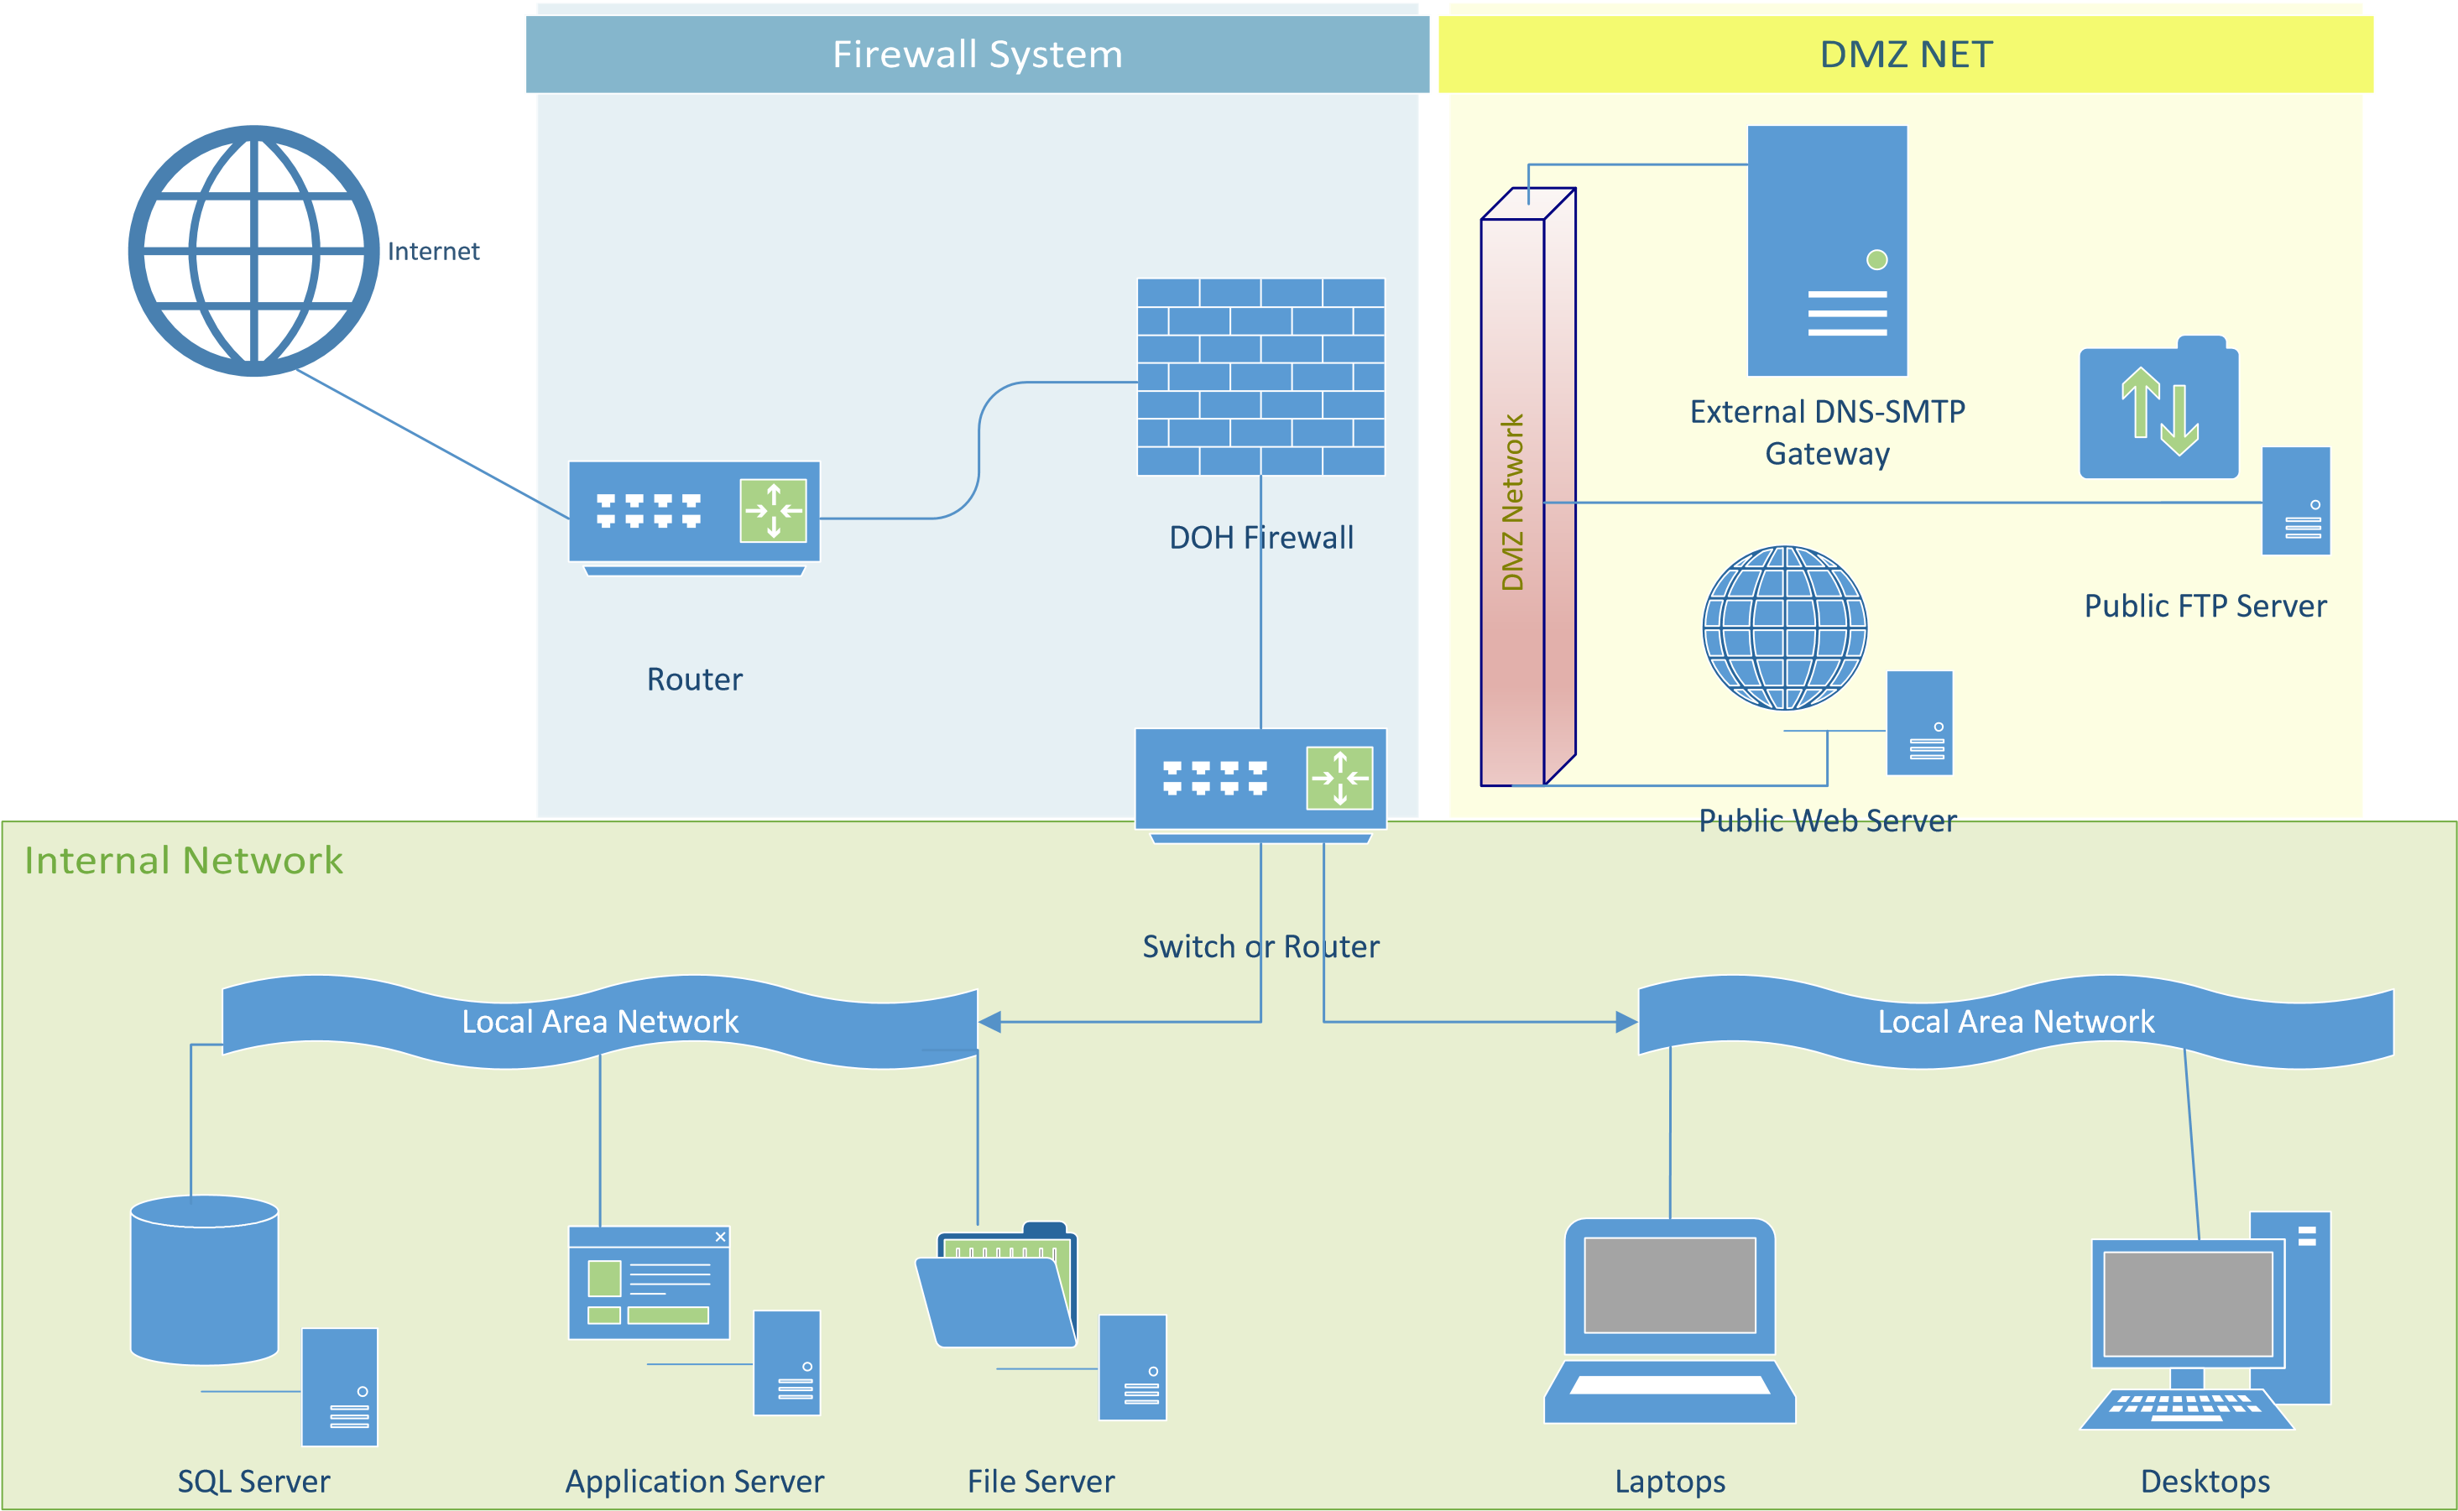
VPN
Wireless
Via Docking Station
User can connect
via intranet or VPN
to synchronize data
between laptop
and base tables on
server.
Local Area Network

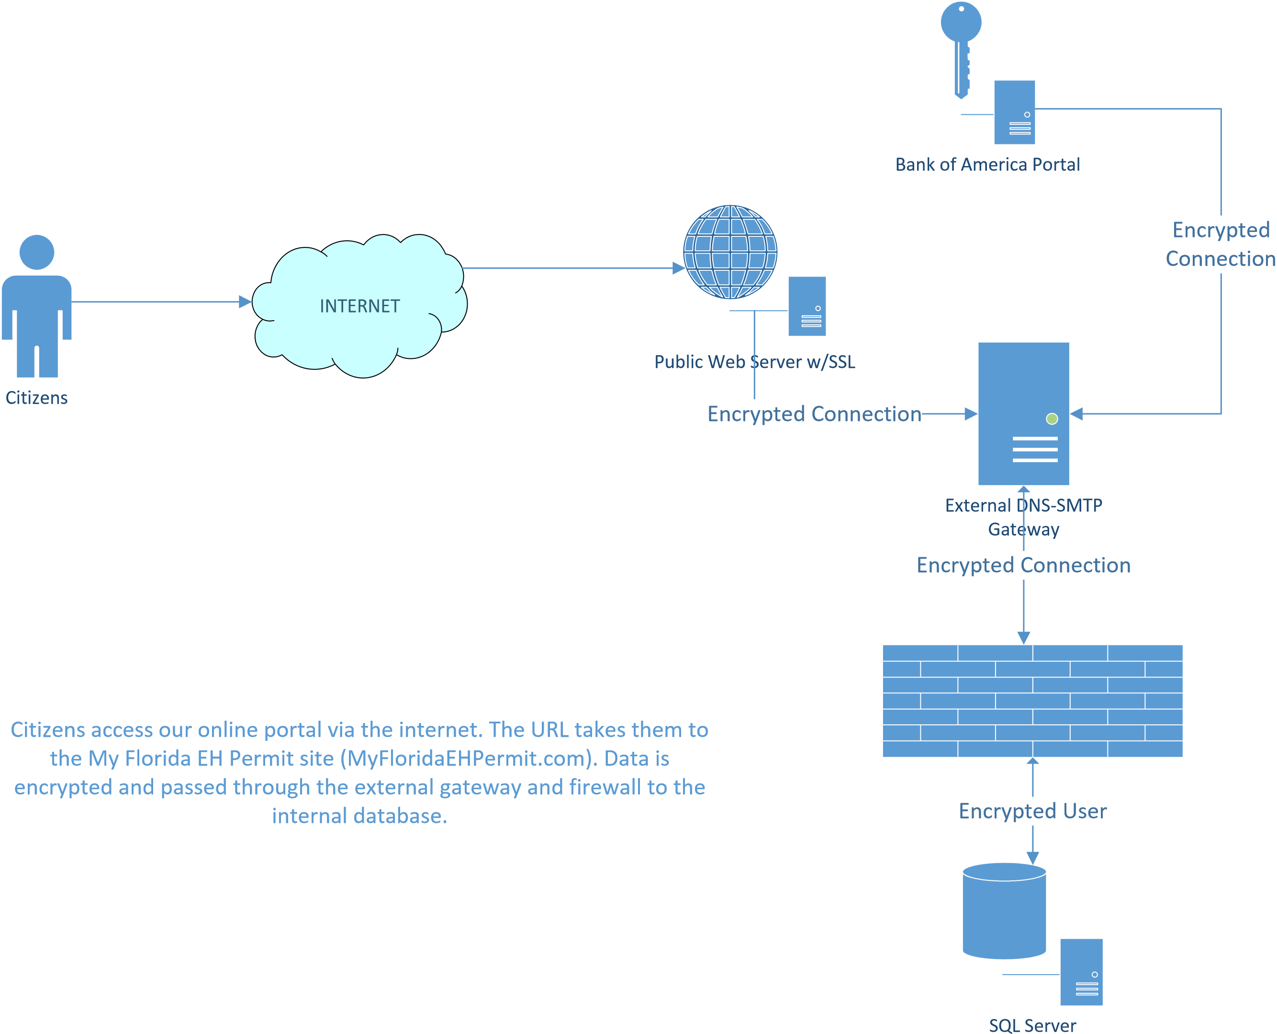

Authorized by Florida Statutes, Section 381.0098
Authorized by Florida Statutes, Section 381.0075
Defined in the Florida Administrative Code, Chapter 64E-11

