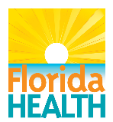

Florida Arbovirus Surveillance Addendum*

January 1-December 31, 2020

In 2020, the following sentinel chicken results were reported:
- 526 West Nile virus (WNV)-positive among 25 counties
- Eight St. Louis encephalitis virus (SLEV)-positive among 7 counties
- 55 Eastern equine encephalitis virus (EEEV)-positive among 16 counties
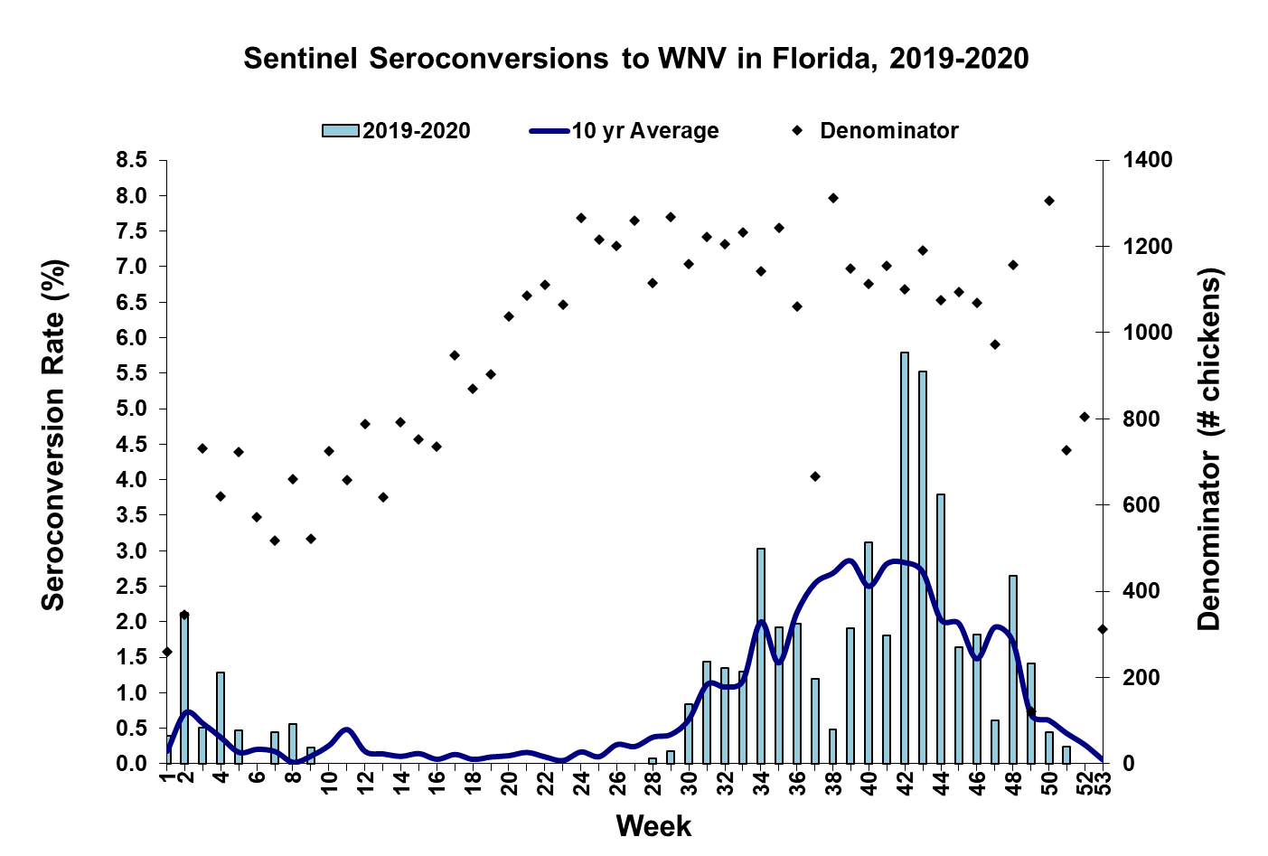

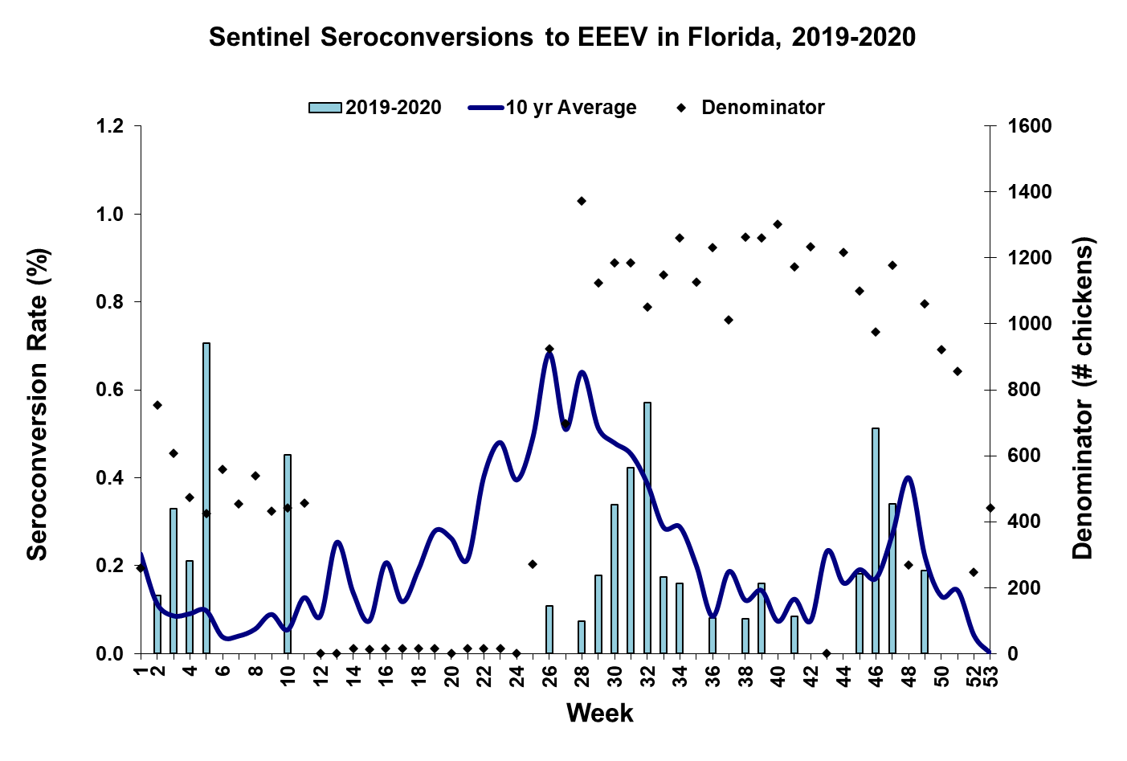

2020 Arbovirus Activity in Sentinel Chickens by County
County | Arbovirus Activity
Alachua | WNV: 2 sentinels (10/22, 11/24)
Bay | WNV: 9 sentinels (8/17, 9/21, 9/28)
Brevard | WNV: 9 sentinels (1/23, 1/24, 9/2, 10/8, 10/14, 10/30, 11/4, 12/4)  EEEV: 3 sentinels (7/15, 7/16, 7/31)  SLEV: 1 sentinel (11/6)
Charlotte | WNV: 13 sentinels (9/11, 10/9, 10/16, 10/23, 10/30, 11/20)
Citrus | WNV: 14 sentinels (1/8, 1/14, 1/21, 7/14, 10/13, 10/20, 11/2, 12/1)  EEEV: 3 sentinels (1/8, 3/2, 9/14)  SLEV: 1 sentinel (11/17)
Duval | WNV: 11 sentinels (8/10, 8/31, 9/14, 9/28, 10/5, 10/19, 10/26)  EEEV: 1 sentinel (9/21)
Hernando | WNV: 6 sentinels (10/13, 10/19, 10/26)  EEEV: 1 sentinel (1/21)
Hillsborough | WNV: 24 sentinels (1/6, 1/21, 1/29, 2/11, 2/18, 2/25, 8/26, 9/8, 9/23, 10/21, 10/28, 11/4, 11/9, 12/2)  EEEV: 1 sentinel (11/9)
Indian River | WNV: 32 sentinels (1/2, 1/9, 1/10, 10/9, 10/15, 10/16, 10/22, 10/23, 10/29, 10/30, 11/24)  SLEV: 1 sentinel (12/17)
Lee | WNV: 167 sentinels (7/6, 7/20, 7/21, 7/27, 7/28, 8/3, 8/4, 8/10, 8/17, 8/18, 8/24, 8/25, 8/31, 9/1, 9/7, 9/8, 9/15, 9/21, 9/22, 9/28, 9/29, 10/5, 10/6, 10/12, 10/13, 10/19, 10/20, 10/26, 10/27, 11/30)  SLEV: 2 sentinels (9/28)
Leon | WNV: 4 sentinels (9/21, 10/12, 10/26)  EEEV: 4 sentinels (7/20, 7/27)
Manatee | WNV: 22 sentinels (1/8, 8/4, 8/12, 9/2, 9/30, 10/21, 10/28, 11/4, 11/10, 12/8)
Martin | WNV: 20 sentinels (7/17, 7/24, 8/7, 8/21, 8/28, 10/16, 10/23, 10/30, 12/4)  EEEV: 1 sentinel (11/6)
Nassau | WNV: 19 sentinels (7/25, 8/15, 8/22, 8/29, 10/3, 10/17, 10/24, 11/7, 11/21)  EEEV: 4 sentinels (7/25, 11/14, 11/21)  SLEV: 1 sentinel (11/7)
Orange | WNV: 10 sentinels (1/6, 8/17, 10/19, 10/26, 11/23, 11/30)  EEEV: 11 sentinels (1/13, 1/27, 1/28, 2/24, 3/2, 8/3, 11/9)
Palm Beach | WNV: 32 sentinels (1/20, 8/3, 8/17, 8/24, 8/31, 10/5, 10/13, 10/20, 10/26, 11/2, 11/30, 12/7, 12/15)  EEEV: 1 sentinel (8/3)
Pasco | WNV: 18 sentinels (1/7, 9/29, 10/13, 10/19, 10/20, 10/27, 11/2, 11/3, 11/6, 11/9, 11/17, 12/1)  EEEV: 1 sentinel (8/31)  SLEV: 1 sentinel (12/23)
Pinellas | WNV: 5 sentinels (8/24, 10/12, 10/26, 11/2)
Polk | WNV: 6 sentinels (10/2, 10/9, 10/16, 10/23, 11/9)
Putnam | WNV: 2 sentinels (7/21, 8/17)  EEEV: 1 sentinel (8/17)
Sarasota | WNV: 37 sentinels (8/14, 9/15, 9/25, 10/13, 10/16, 10/20, 10/23, 10/27, 10/30, 11/6, 11/9, 11/16, 11/20, 11/24)  EEEV: 1 sentinel (7/28)
St. Johns | WNV: 6 sentinels (11/9, 11/30)  EEEV: 3 sentinels (8/4, 8/10, 11/30)  SLEV: 1 sentinel (11/9)
St. Lucie | WNV: 31 sentinels (7/23, 8/6, 8/13, 8/27, 10/1, 10/15, 10/22, 11/5, 11/23, 12/3)
Volusia | WNV: 1 sentinel (5/4)  EEEV: 4 sentinels (2/24, 5/18, 5/30, 10/5)
Walton | WNV: 26 sentinels (7/27, 8/17, 8/24, 8/31, 9/8, 9/14, 9/28, 10/12, 10/19, 11/2, 11/9, 11/30, 12/7)  EEEV: 15 sentinels (6/22, 7/6, 7/27, 8/3, 8/10, 8/17, 9/21, 11/2, 11/9, 11/16, 11/17, 11/30)

*Sentinel chicken data is provided by the Florida Department of Health Bureau of Public Health Laboratories. A subset of sentinel chickens requiring specialized testing were reported late due to the Coronavirus disease-2019 (COVID-19) response.

Acknowledgements and Data Sources

Contributors: Andrea Morrison, PhD, MSPH, Rebecca Zimler, PhD, Catherine McDermott, MPH, MHS, and Danielle Stanek, DVM, DOH Bureau of Epidemiology; Lea Heberlein-Larson, DrPH; Alexis LaCrue, PhD, MS; Maribel Castaneda, and Valerie Mock, BS; DOH Bureau of Public Health Laboratories; Carina Blackmore, DVM, PhD, DOH Division of Disease Control and Health Protection.

For more surveillance information, please see the DOH website at: www.floridahealth.gov/diseases-and-conditions/mosquito-borne-diseases/surveillance.html

For arbovirus surveillance information for the United States, please see the Centers for Disease Control and Prevention website at: www.cdc.gov/ncidod/dvbid/westnile/surv&control.htm

