|  |  |  |  |  |  |  |  |  |  |  |  |  |  |  |  |  |  |  |  |  |  |
| --- | --- | --- | --- | --- | --- | --- | --- | --- | --- | --- | --- | --- | --- | --- | --- | --- | --- | --- | --- | --- | --- |
| **Directions for Submitting Mosquito Pools for Arbovirus Testing**  **Prior to sending samples, BPHL Tampa must be contacted.**   1. **Mosquitoes should be non-fed females only.** 2. **Pools must contain no more than 50 mosquitoes and be sorted by species, collection site, and week/night of collection**    1. **Mosquito pool species with known disease transmission to humans will be prioritized and tested first. Any other species will be tested on a case-by-case basis.**    2. **Listed below are mosquito species known to transmit arboviruses to humans in Florida.**  |  |  | | --- | --- | | **Genus and species** | **Virus** | | ***Aedes aegypti*** | ***Chikungunya (CHIKV), Dengue (DENV), Zika*** | | ***Aedes albopictus*** | ***CHIKV, DENV, Zika*** | | ***Aedes atlanticus*** | ***Eastern Equine Encephalitis (EEEV)*** | | ***Aedes sollicitans*** | ***EEEV*** | | ***Aedes vexans*** | ***EEEV*** | | ***Coquellitidia perturbans*** | ***EEEV*** | | ***Culiseta melanura*** | ***EEEV*** | | ***Culex nigripalpus*** | ***EEEV, St. Louis Encephalitis (SLEV), West Nile Encephalitis (WNV)*** | | ***Culex quinquefasciatus*** | ***EEEV, WNV*** |  1. **Mosquito pools can be stored in 1.5 ml microcentrifuge tubes. Tubes must be labeled with the following information:**     1. **Submitter ID**    2. **Species**    3. **Collection Date** 2. **Mosquitoes must be shipped cold, overnight, within 72 hours of collection.**    1. **If samples are shipped within 24 hours of collection, they can be shipped with ice packs.**    2. **If samples are shipped between 24-72 hours of collection, they can be stored at -80℃ and shipped with dry ice.**   **Please, complete all sections of the submission form to prevent delays in sample processing and reporting.** | **Direct Questions To:****Lead Scientist- Viral Serologic Testing and Arbovirus Surveillance**Dr. Alexis N. LaCrueBureau of Public Health Laboratories-Tampa3602 Spectrum BlvdTampa, FL 33612-9401Phone: (813) 233-2315Fax: (813) 974-5776E-mail: Alexis.LaCrue@flhealth.gov |

Bureau of Public Health Laboratories Contact Information

|  |  |
| --- | --- |
| **Laboratory Director**  Dr. Andrew Cannons  Phone: (813) 233-2277  Fax: (813) 974-3425  E-mail: [Andrew.Cannons@flhealth.gov](mailto:Andrew.Cannons@flhealth.gov) | **Virology Administrator**  Lea Heberlein-Larson  Phone: (813) 233-2307  Fax: (813) 974-5776  E-mail: [Lea.Heberlein-Larson@flhealth.gov](mailto:Lea.Heberlein-Larson@flhealth.gov) |
| **Assistant Lead Scientist- Viral Serologic Testing and Arbovirus Surveillance**  Maribel Castaneda  Phone: (813) 233-2342  Fax: (813) 974-5776  E-mail: [Maribel.Castaneda@flhealth.gov](mailto:Maribel.Castaneda@flhealth.gov) | **Scientist- Viral Serologic Testing and Arbovirus Surveillance**  Bryan Benko  Phone: (813) 233-2292  Fax: (813) 974-5776  E-mail: [Bryan.Benko@flhealth.gov](mailto:Bryan.Benko@flhealth.gov) |

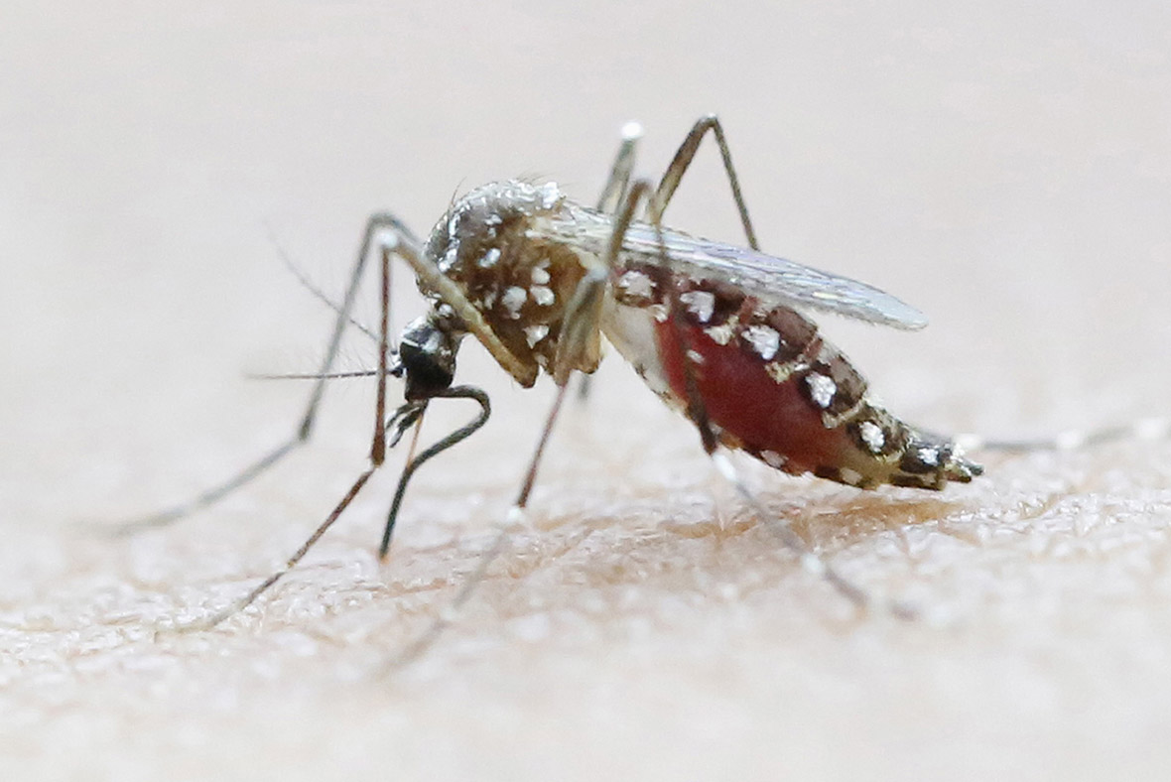

Arbovirus Surveillance:

Mosquito Pool Molecular Analysis Request Form



|  |  |
| --- | --- |
| **DOH LAB USE ONLY** | |
| Date Received: |  |
| Date Reported: |  |
| Comments: | |
|  | |
| Bureau of Public Health Labs-Tampa Contact:  Dr. Alexis N. LaCrue  Phone: 813-233-2315  E-mail: [Alexis.LaCrue@flhealth.gov](mailto:Alexis.LaCrue@flhealth.gov) | |

|  |  |
| --- | --- |
| **Submitter Information** | |
| Name: |  |
| E-mail: |  |
| Phone number: |  |
| Organization: |  |
| Address: |  |
| City: |  |
| State: |  |
| Zip Code: |  |
| County: |  |

|  |  |  |  |  |  |  |
| --- | --- | --- | --- | --- | --- | --- |
| **Specimen Collection Data** | | | | | | **DOH LAB USE ONLY** |
| **Collection Date** | **Submitter Sample ID** | **Species** | **Site Location\***  **(GPS Coordinates or**  **Address of Collection)** | **# Per Pool**  **(50 max)** | **Trap Type** | **LAB NUMBER** |
|  |  |  |  |  |  |  |
|  |  |  |  |  |  |  |
|  |  |  |  |  |  |  |
|  |  |  |  |  |  |  |
|  |  |  |  |  |  |  |

*Submission guidelines are on the back*

**\*Please note, site name will not suffice for site location. A physical address or GPS coordinates must be included in the column.**

|  |  |  |  |  |  |  |
| --- | --- | --- | --- | --- | --- | --- |
| **Specimen Collection Data** | | | | | | **DOH LAB USE ONLY** |
| **Collection Date** | **Submitter Sample ID** | **Species** | **Site Location\***  **(GPS Coordinates or**  **Address of Collection)** | **# Per Pool**  **(50 max)** | **Trap Type** | **LAB NUMBER** |
|  |  |  |  |  |  |  |
|  |  |  |  |  |  |  |
|  |  |  |  |  |  |  |
|  |  |  |  |  |  |  |
|  |  |  |  |  |  |  |
|  |  |  |  |  |  |  |
|  |  |  |  |  |  |  |
|  |  |  |  |  |  |  |
|  |  |  |  |  |  |  |
|  |  |  |  |  |  |  |
|  |  |  |  |  |  |  |
|  |  |  |  |  |  |  |
|  |  |  |  |  |  |  |