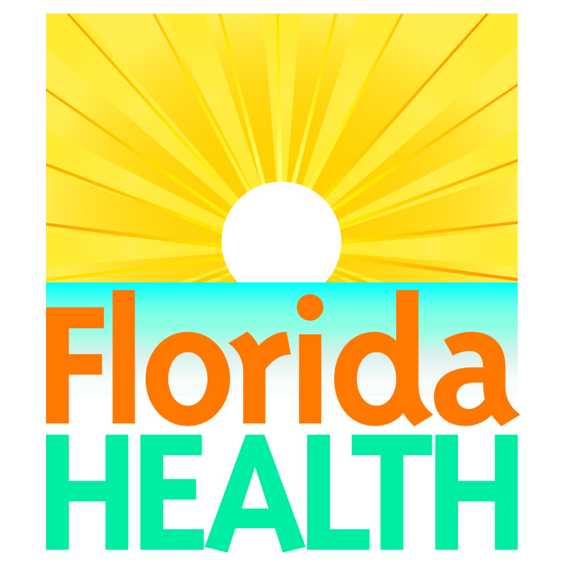

APPROVED BODY PIERCING COURSE
$100.00 Per Person

Certificate of Completion - Upon completion of class you will receive
certificate of completion. All Body Piercers are required to attend an annual
training class. Pre-registration required
This course meets the requirements of F.A.C. 64E-19.
Registration is Easy
1. WHERE: Florida Department of Health- Duval County
515 W. 6th Street
Jacksonville, Fl 32206
WHEN: Monday, January 24th, 2022 9am – 1pm
2. CHOOSE YOUR METHOD OF REGISTRATION
PHONE (904) 253-2578 (pay by credit card) Email Registration Form to: Cassandra.haverkamp@flhealth.gov
3. CHOOSE YOUR METHOD OF PAYMENT
PHONE: Contact the cashier at (904) 253-2578 to pre-pay in the amount of $100.00 (Non-refundable) If class is missed a future date can by chosen as space permits.
4. REGISTRANT INFORMATION
(One registrant per form- please print or type)

FIRST NAME _____________________________________________

LAST NAME ______________________________________________

BUSINESS NAME _________________________________________

ADDRESS ________________________________________________

CITY _______________________________

ZIP CODE ___________________________

TELEPHONE __________________________________

OTHER ______________________________________

