In The Event Of Accident,
Damage, Loss, Theft, Spill, Or Contamination Involving

RADIOACTIVE MATERIALS

IMMEDIATELY

NOTIFY

Telephone Number
Licensee’s Radiation Safety Officer:  Enter Radiation Safety Officer Name | Duty  Enter Phone Number

After Duty:
Enter one or more phone numbers Ex: Home/Cell/Beeper

For State Radiation Emergency
Notification Or Assistance Call:
(407) 297-2095*
*Monitored 24 hours a day
In the event of suspected contamination:
1. SEAL OFF CONTAMINATED AREA, CLOSE WINDOWS, DOORS, AND VENTILATION TO OTHER AREAS.
2. LIMIT ACCESS TO CONTAMINATED AREAS, KEEP PEOPLE OUT!
3. DO NOT TRACK RADIOACTIVITY THROUGHOUT THE BUILDING REMEMBER YOUR SHOES AND CLOTHING MAY BE CONTAMINATED!
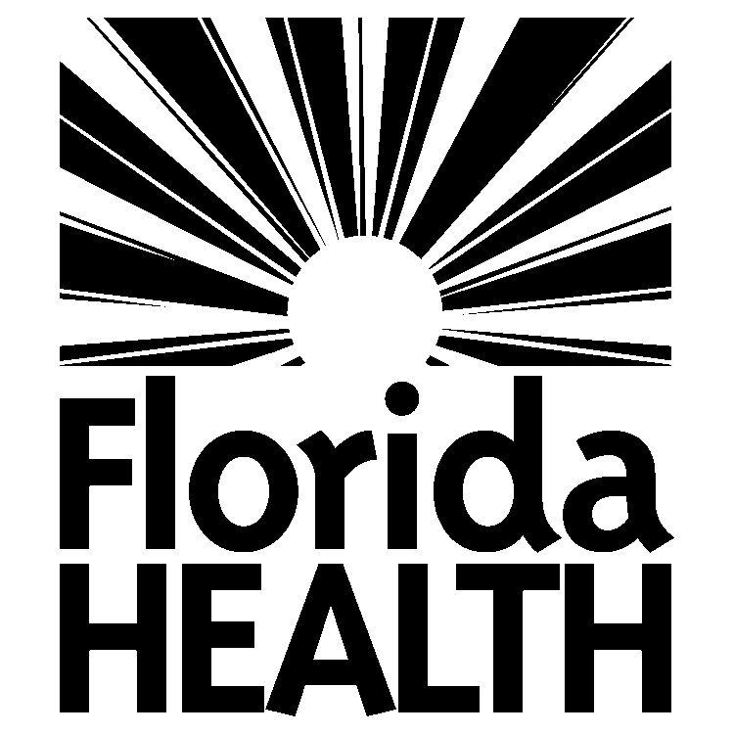
State of Florida
Department of Health
Bureau of Radiation Control
4052 Bald Cypress Way, Bin #C21
Tallahassee, Florida 32399-1741

