

This document will assist persons with determining what type of tattoo license they need.

1. **Tattoo Artist Licensure Requirements, page 2**
2. **Tattoo Artist with an Active License, page 3**
3. **Tattoo Artist with No License, page 3**
4. **Tattoo Artist with unacceptable License, page 4**
5. **Tattoo Artist with License issued by County or City, page 4**

Tattoo Artist Licensure Requirements

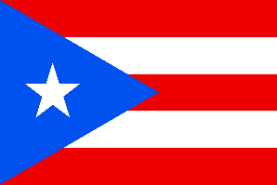In Florida,

**A Tattoo Artist License requires the following:**

* Completed [Application for Tattoo Artist License ($60, local county health department may charge additional fee)](http://www.floridahealth.gov/environmental-health/tattooing/_documents/Tattoo%20Application%20and%20County%20Contact%20Info.pdf).
* At least 18 years of age
* Copy of government-issued photo ID
* Documentation of a completed tattoo [Education Courses](http://www.floridahealth.gov/environmental-health/tattooing/tattoo-educational-materials.html)  with a passing score of at least 70%.

**A Guest Tattoo Registration requires the following:**

* Completed [Application for Guest Tattoo Artist Registration. (170kb PDF) ($35).](http://www.floridahealth.gov/environmental-health/tattooing/_documents/Application%20for%20Guest%20Tattoo%20Artist%20Registration1.pdf)
* **Proof of active license, registration, or certification outside of Florida.**
* Documentation of completed tattoo [Education Courses](http://www.floridahealth.gov/environmental-health/tattooing/tattoo-educational-materials.html) with a passing score of at least 70% or comparable education and examination that meet or exceed the requirements of s. 381.00775(2)(b)(4), Florida Statutes.
* At least 18 years of age.
* Copy of government-issued photo ID.

**If your state or country does not require a tattoo artist license, registration, or certification, you must apply for a**[Florida Tattoo Artist License.](http://www.floridahealth.gov/environmental-health/tattooing/_documents/Tattoo%20Application%20and%20County%20Contact%20Info.pdf)

**Tattoo Artists from these jurisdictions have been determined to meet the educational requirements for the Guest Tattoo Artist Registration.**

**Puerto Rico**

**Italy**

**Oregon**

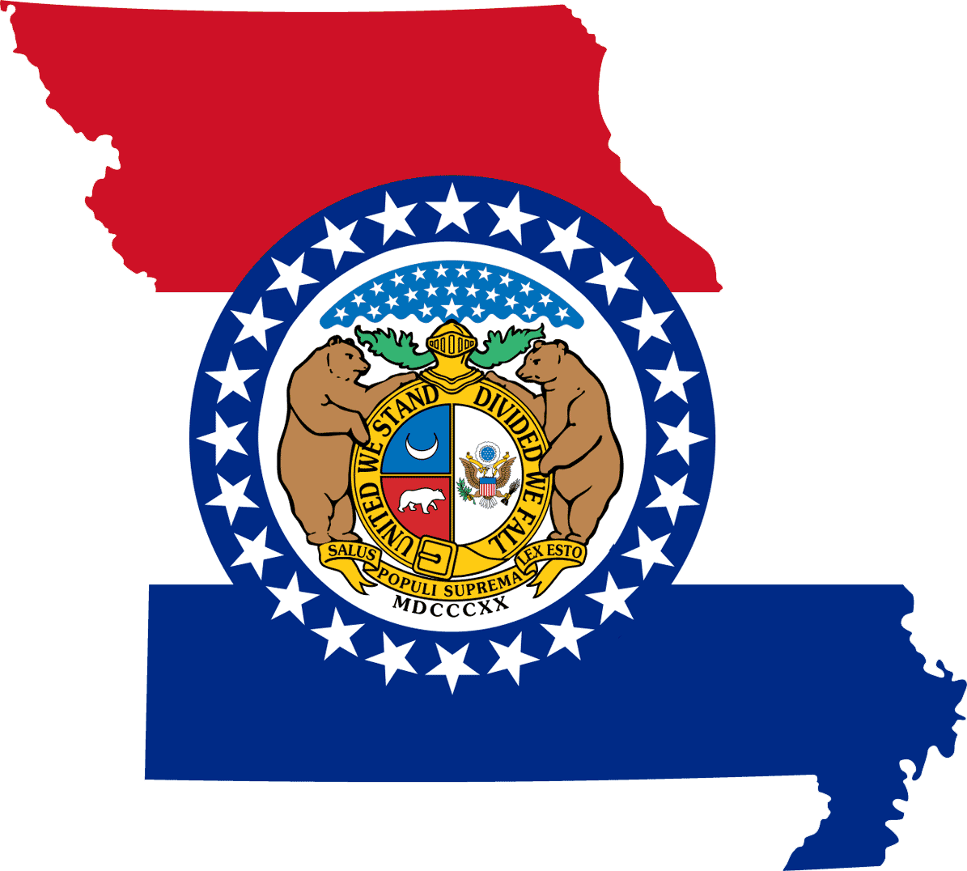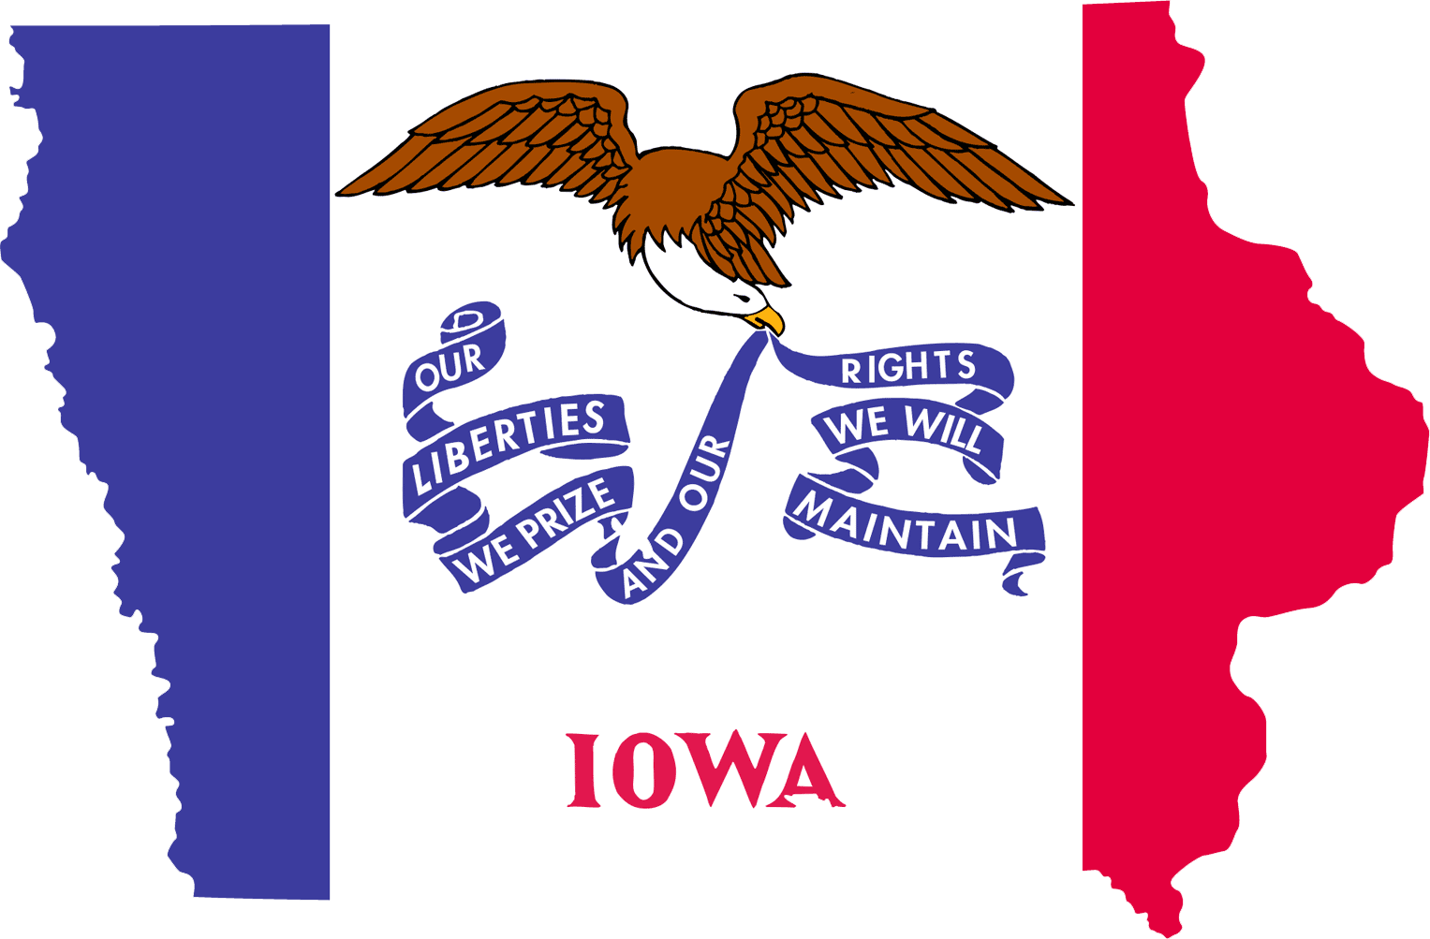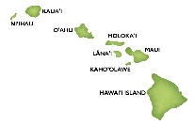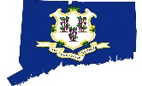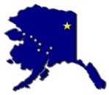 **States and Countries that Issue Tattoo Artist Licenses**

**Tattoo Artists holding an active tattoo artist license, certification, or registration from the following states/countries qualify for the Guest Tattoo Artist Registration or Tattoo Artist License. These artists must complete a Department approved Bloodborne Pathogen and Communicable Diseases course.**

1. [Alaska](http://dec.alaska.gov/eh/fss/Public_Facilities/Body_Art_Home.html) 10. [North Carolina](http://ehs.ncpublichealth.com/faf/pti/tattoos.htm)
2. [Arkansas](http://www.healthy.arkansas.gov/programs-services/topics/tattoo-and-body-art) 11. [Oklahoma](https://www.ok.gov/health/Protective_Health/Consumer_Health_Service/Body_Piercing_and_Tattooing/Body_Piercing_and_Tattoo_Apprentice_Program/index.html)
3. [Connecticut](https://www.jud.ct.gov/lawlib/law/tattoo.htm) 12. [Rhode Island](http://www.ri.gov/search/result.php?q=tattoo+license)
4. [Hawaii](http://health.hawaii.gov/san/tattoo-lists/) 13. [South Dakota](https://www.spcp.org/us-state-legislative-information/legislation-south-dakota/)

1. [Iowa](http://idph.iowa.gov/tattoo) 14. [Tennessee](https://www.tn.gov/health/health-program-areas/eh/eh-programs/eh-tattoo.html)
2. [Maine](http://www.maine.gov/dhhs/mecdc/environmental-health/el/business/business-answers-tattoos.htm) 15. [Vermont](https://legislature.vermont.gov/statutes/fullchapter/26/079)
3. [Mississippi](https://msdh.ms.gov/msdhsite/_static/resources/879.pdf) 16. [Virginia](http://www.dpor.virginia.gov/uploadedFiles/MainSite/Content/Boards/BarberCosmo/A425REGS_Tattooing.pdf)
4. [Missouri](https://pr.mo.gov/tattooing-rules-statutes.asp) 17. [Washington](http://www.dol.wa.gov/business/tattoo/laws.html)
5. [New Hampshire](https://www.oplc.nh.gov/body-art/licensing.htm) 18. [[Wisconsin](https://www.portsmouth.gov.uk/ext/the-council/transparency/the-tattooing-hygiene-rating-scheme)](https://dsps.wi.gov/Pages/Professions/TattooistBodyPiercer/Default.aspx)

10. [New York](https://www.health.ny.gov/community/body_art/) 19. [Portsmouth, U.K.](https://www.portsmouth.gov.uk/ext/the-council/transparency/the-tattooing-hygiene-rating-scheme)

States and Countries that do not Issue Tattoo Artist Licenses

**The following states/countries do not license, certify, or register tattoo artists. Therefore, tattoo artists from these states *are not* eligible to apply for a Guest Tattoo Artist Registration, but may apply for a Tattoo Artist License and complete required Department approved Bloodborne Pathogen and Communicable Diseases Course.**

1. Arizona 9. Michigan
2. British Columbia, Canada 10. Montana
3. Delaware 11. New Jersey
4. Idaho 12. North Dakota
5. Illinois 13. Ohio
6. Indiana 14. South Carolina
7. Louisiana 15. Utah
8. Maryland 16. West Virginia

States that Issue Unacceptable Tattoo Artist Licenses

**Tattoo artists from the following states hold licenses, certifications, or registrations that do not state “Tattoo Artist” and therefore, *are not* acceptable. Tattoo Artists from these states need to apply for a Tattoo Artist License, unless the artist can obtain documentation from the licensing jurisdiction that the license was issued specifically for tattooing.**

1. [Alabama](http://www.alabamapublichealth.gov/foodsafety/body-art.html) 7. [Nebraska](http://www.sos.ne.gov/rules-and-regs/regsearch/Rules/Health_and_Human_Services_System/Title-172/Chapter-044.pdf)

1. [Georgia](https://dph.georgia.gov/tattoo-studios) 8. [Nevada](http://www.southernnevadahealthdistrict.org/body-art/tattoo-regulations.php)
2. [Kansas](http://www.kansas.gov/kboc/BAStatsandRegs.htm) 9. [New Mexico](http://www.rld.state.nm.us/boards/body-art-practitioners.aspx)
3. [Kentucky](https://chfs.ky.gov/agencies/dph/dphps/fsb/Pages/tattoo-piercing.aspx)
4. [Massachusetts](http://www.mass.gov/eohhs/docs/dph/environmental/sanitation/bodyart-model-regs.pdf)
5. [Minnesota](http://www.health.state.mn.us/divs/hpsc/hop/tattoo/brochure.html)

Tattoo Artist Licenses Issued by County or City

**The following states do not have statewide regulations for tattooing. In these states, some of the counties or cities may license, certify, or register the tattoo artists. Check with tattoo artists from these states to determine if they have been issued a tattoo artist license, certification, or registration.**

1. [California](http://www.leginfo.ca.gov/pub/11-12/bill/asm/ab_0251-0300/ab_300_bill_20111009_chaptered.html) 6. [Pennsylvania](https://ecode360.com/8121115)
2. [Colorado](https://dph.georgia.gov/tattoo-studios) 7. [Texas](https://www.elpasotexas.gov/planning-and-inspections/business-licensing/tattoo-and-body-artist-license)
3. [Georgia](https://dph.georgia.gov/tattoo-studios) 8. [Wyoming](http://www.laramiecounty.com/_departments/Health/_pdfs/Body_Art/Body%20Art%20Regs2.10.11.pdf)
4. [New York](https://www.health.ny.gov/community/body_art/)
5. [Nevada](http://www.southernnevadahealthdistrict.org/body-art/tattoo-regulations.php)

