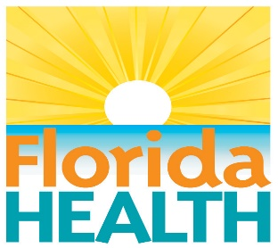 | Florida Department of Health  Photo Release Form

Photo/Digital Image (Attach printed copy)

Description: 2022 EMS State Awards

I hereby give my informed written consent for the above-described photographs to be used specifically by the Florida Department of Health.
It is my understanding the Florida Department of Health may use such material until I revoke this authorization in writing.

_______________________________________________________________
Agency Name/ Contact Name (Print: Last Name, First Name, Middle Initial)
Address: ______________________________________________________________________
________________________________________________________________
________________________________________________________________

Telephone Number: (_______)_________________________________________

________________________________________________________________

If applicable, print name of Parent or Legal Guardian (Last Name, First Name, Middle Initial)

Signature: _______________________________________Date: ________________________
(Signature of Parent or Legal Guardian required if under 18 years of age)
________________________________________________________________

Witness Name (Print: Last Name, First Name, Middle Initial)
________________________________________________________________
Witness Signature
_ _ _ _ _ _ _ _ _ _ _ _ _ _ _ _ __ _ _ __ _ _ __ _ _ _ __ _ _ _ _ _ _ _ _ _ _ _ _ _ __ _ _ __ _ _ __ _ _ _ __

I am revoking this consent. Date: ____________________________

I understand I may only revoke consent for items I have provided permission, and every effort will be made to remove the item when possible within a reasonable time frame. I also understand this may have been copied without permission and I agree not to hold the Florida Department of Health responsible for instances of these violations.

Signature: ____________________________________________________________________
(Signature of Parent or Legal Guardian required if under 18 years of age)

