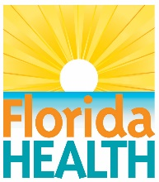
 | FLORIDA DEPARTMENT OF HEALTH  EMERGENCY MEDICAL SERVICES (EMS) SECTION  2022 STATE EMS AWARDS | 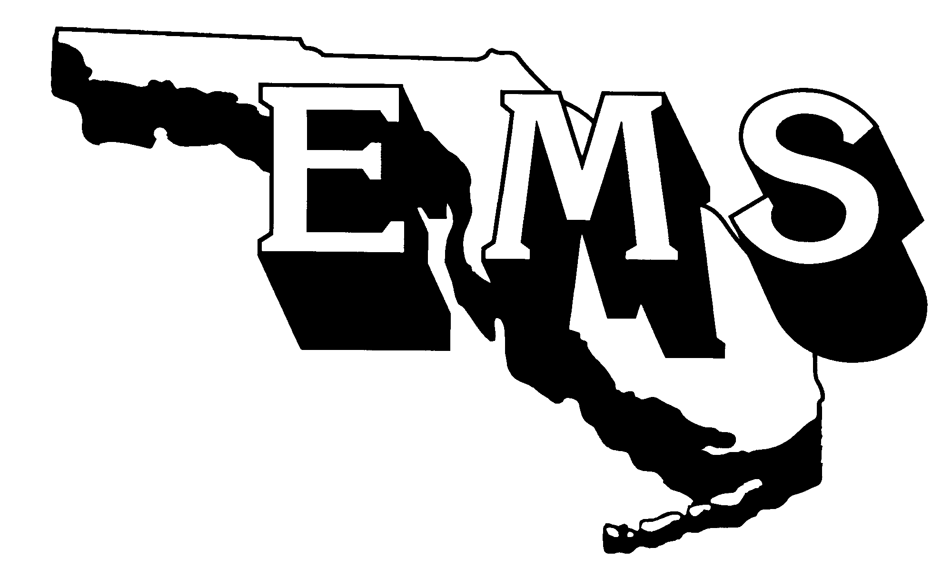

PURPOSE

The state of Florida Department of Health would like to recognize the efforts our front-line providers are doing EVERY DAY. We ask that your department consider a nomination for ONE or MORE of the available categories.

APPLICATION PROCESS
To nominate an individual or organization please submit the following:

Nomination Entry Guidelines: The nominee must NOT have any administrative actions pending with the Florida Department of Health.
Nominees with pending administrative actions will be automatically disqualified.

Nomination Entry Sheet: Please complete the attached nomination entry sheet and indicate the award for each you are applying for. You must complete one entry sheet for EACH nomination.

Summary Statement Guidelines: Prepare a statement to depict the nominee’s qualities and contributions to EMS in Florida. Include why the nominee is exceptionally qualified and should be selected for this award. Break down the nomination criteria by specifics and describe how the nominee has excelled in each area specified in the criteria. Be specific. If you do not address EACH component of the nomination, you will lose points.

Supporting Materials: Supporting materials can include articles, letters, résumé (if necessary), and any additional information to support the candidate’s nomination.

Electronic Photograph: You MUST submit an electronic photograph (high-resolution JPEG) of the nominee and include the attached photo release form completed and signed by that individual or organization. This photo will be incorporated into the awards ceremony in the event the nominee is selected as a winner.

Time Frame: January 1, 2021, to June 30, 2022

CHECK FOR ALL THE FOLLOWING ITEMS BEFORE YOU SUBMIT THE NOMINATION:

Selected the most appropriate category for the nominee
Nomination form and support materials included
Electronic photograph (high-resolution JPEG) of nominee enclosed
Signed release form(s) enclosed for all photos or videos submitted
Summary statement follows the guidelines listed above

****Failure to provide ALL the necessary information will lead to the disqualification of the nominee.

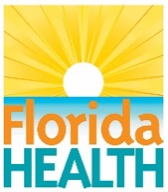 | FLORIDA DEPARTMENT OF HEALTH  EMERGENCY MEDICAL SERVICES SECTION  2022 STATE EMS AWARDS
2022 NOMINATION ENTRY SHEET

Check only one category for each nomination. Nominate only one person, agency, or organization. (See pages 3 and 4 for the criteria for each award listed below.)

911 Public Safety Telecommunicator
Emergency Medical Technician (EMT)
EMS Education
EMS Memorial
EMS Provider
Larry S. Jordan – EMS Hall of Fame
Marilyn Crook EMS Pioneer
Mobile Integrated Health
Paramedic
Raymond H. Alexander - EMS Medical Direction

Nominee’s Name:

Organization (if applicable):

Address:

City: Zip:

Phone: Fax: Email:

NOMINATION SUBMITTED BY:

Nominator’s Name:

Organization (if applicable):

Address:

City: Zip:

Phone: Fax: Email:

Prepare a summary statement describing how the nominee meets the award criteria. Please refer to the summary statement guidelines on page one.

All applications must be emailed or postmarked by August 15, 2022. Mailed materials (see checklist on page 1) should be sent to:
Kaylin Williams / Advisory Council Coordinator
Bureau of Emergency Medical Oversight
4052 Bald Cypress Way, Bin A22
Tallahassee, Florida 32399-1722
OR
Email: EMSAdvisoryCouncil@flhealth.gov / EMS@flhealth.gov
911 Public Safety Telecommunicator
This award recognizes an individual who:
- has demonstrated outstanding effort in processing a medical emergency call; and
- has demonstrated outstanding efforts in educating the public on 911.

A copy of the nominee processing a call must be included within your submission
Emergency Medical Technician
This award recognizes an EMT who:
- is a non-administrative, certified EMT whose primary job is direct patient care;
- has demonstrated exceptional qualities in one or more of the following areas: quality assurance/improvement, patient care, medical control, disaster preparedness, or public education and/or training; and
- has acted “above and beyond the call of duty” in response to the EMS community and/or profession (please elaborate as to how the individual exceeded normal day-to-day job functions while on duty).
EMS Education
This award recognizes an individual (or organization) who:
- is recognized as an educator with a Florida EMS training program, Florida-approved continuing education provider, or licensed EMS service;
- has assumed a leadership role in the field of EMS education;
- has made a positive contribution to EMS education in the community, state, or nation.
EMS Memorial
This category recognizes all individuals who have lost their lives in the line of duty. Please report any of these unfortunate casualties to the EMS program that occurred during the review period. These individuals will be recognized for their sacrifice at the awards ceremony.
EMS Provider
This award recognizes a licensed EMS provider that:
- participates in the Florida Prehospital EMS Tracking and Reporting System (EMSTARS);
- has no administrative action pending from the Department of Health;
- has assumed a leadership role in the Florida EMS system and community;
- has demonstrated outstanding initiative in the area of public education and/or training; and
- has demonstrated excellence in the areas of quality assurance/improvement and medical control protocol development/implementation.
Larry S. Jordan - EMS Hall of Fame
This award recognizes an individual who:
- is viewed as a national advocate for EMS, increasing public attention and action at the highest levels
- has devoted a significant part of his/her life to promoting and advancing prehospital emergency care
- has worked to change the manner in which we care for patients throughout the entire continuum of care;
- has been active on numerous committees and boards at the state level;
- has had EMS-related works published in journals, textbooks, or other publications
Marilyn Crook EMS Pioneer Award
This award recognizes an individual who has advanced the EMS profession and/or system:
- through visionary leadership:
  - by setting directions and creating patient focus, clear and visible values, and high expectations while balancing the needs of all EMS stakeholders; and
  - by ensuring the creation of strategies, systems, and methods for achieving performance excellence, stimulating innovation, building knowledge and capabilities, and ensuring EMS sustainability.
- through managing for innovation. Innovation means making meaningful changes to improve EMS products, services, programs, processes, and operations and to create new value for EMS stakeholders; and
- by promoting the use of best practices by building internal and external partnerships to address common issues, enhance communication, and evaluate progress to adapt to changing conditions in the EMS system.
Mobile Integrated Health
This award recognizes a Mobile Integrated Health care program that:
- is a certified EMS-based Mobile Integrated Health care program in Florida; and
- has demonstrated exceptional outcomes improving the health of their community with a special emphasis on mental health, substance abuse, high system utilizer’s reduction, general health, and wellness, fall prevention, community education, and prevention programs; and,
- has demonstrated exceptional outcomes working with primary care providers, and mental health (including substance use dependence) resources and/or care options for high-risk patient populations to reduce the burden these individuals have on community systems; and,
- has demonstrated their program’s ability to help bridge the gap between access to primary care services and the needs of their community; and,
- may include your program’s innovative approach to collaboration through the use of telehealth and/or other programs implemented to address clinical issues and patient needs, as well as provide support, resources, and education. Include how organizations are participating in the collaboration; and
- how the collaboration was identified as a need; and
- demonstrates qualitative and/or quantitative outcomes that explain how the initiative is successfully addressing clinical issues and patient needs, as well as providing support, resources, and education to improve population health.
Paramedic
This award recognizes a paramedic who:
- is a non-administrative, certified paramedic whose primary job is direct patient care;
- has demonstrated exceptional qualities in one or more of the following areas: quality assurance/improvement, patient care, medical control, disaster preparedness, or public education and/or training; and
- has acted “above and beyond the call of duty” in response to the EMS community and/or profession (please elaborate as to how the individual exceeded normal day-to-day job functions).

Raymond H. Alexander - EMS Medical Direction
This award recognizes an individual who:
- is a licensed Florida physician;
- has assumed a leadership role in EMS within the community or state;
- has demonstrated excellence in the areas of quality assurance/improvement and medical control;
- has successfully promoted the use of new medical trends and technologies.

Summary Statement

