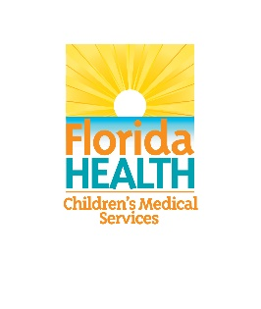
Designation and Certification Subcommittee Meeting
June 3, 2020
10:00AM – 11:00AM
Conference Call Line: 888-585-9008
Participant Code/Conference Room: 662-715-645
Agenda
10:00AM – 10:10AM | Welcome & Roll Call | Erick Quevedo, Chair
10:10AM – 10:20AM | Member Introductions | Erick Quevedo, Chair
10:20AM – 10:35AM | Introduction to Subcommittee’s tasks and goals:  - Identify Successful Models  - Annual and Ongoing training requirements  - Monitoring and Accountability  - Other Goals and Objectives | Erick Quevedo, Chair
10:35AM – 10:55AM | Open Discussion | Erick Quevedo, Chair
10:55AM – 11:00AM | Next Steps:  - Follow-up Tasks & Research  - Next Meeting Topics  - Next Meeting Date | Erick Quevedo, Chair
11:00AM | Adjourn | Erick Quevedo, Chair

