HEADQUARTERS
Christopher Gainous
DOH Volunteer Health Services Supervisor
4052 Bald Cypress Way, Bin # C15
Tallahassee, FL 32399-1743
Phone: (850) 245-4104, © (850)728-7069
E-mail: Christopher.Gainous@flhealth.gov

REGION 1&2 – Bay, Calhoun, Escambia, Holmes, Jackson, Okaloosa, Santa Rosa, Walton, Washington, Franklin, Gadsden, Gulf, Jefferson, Lafayette, Leon, Liberty, Madison, Taylor, Wakulla

Susan Prescott
Florida Department of Health in Walton County
362 State HWY 83
De Funiak Springs, Fl. 32433
Phone: (850) 408-6427
E-mail: Susan.Prescott@flhealth.gov

REGION 3 – Alachua, Baker, Bradford, Clay, Columbia, Duval, Flagler, Hamilton, Nassau, Putnam, St. Johns, Suwannee, Union, Volusia
Lori Thompson
Florida Department of Health in St. Johns County
200 San Sebastian View
St. Augustine, FL 32084
Phone: (904) 588-8307
E-mail: Lorraine.Thompson2@flhealth.gov

REGION 4 – Citrus, Dixie, Gilchrist, Lake, Levy, Hernando
Marion, Pasco, Pinellas, Sumter

Nicola Lemonious
Florida Department of Health in Lake County
16140 US HWY 441
Eustis, FL 32726
Phone: (352) 551-8066
E-mail: Nicola.Lemonious@flhealth.gov

REGION 5 – Orange, Seminole, Osceola
LaRaine M. Berkeley
Florida Department of Health in Orange County
6101 Lake Ellenor Drive
Orlando, Fl. 32809
Phone: (407) 516-7736
E-mail: Laraine.Berkeley@flhealth.gov

REGION 6 – Charlotte, Desoto, Hardee, Manatee, Polk, Sarasota,
Hillsborough

Mariely Mujica Pérez
Florida Department of Health in Polk County
1290 Golfview Ave
Bartow, Florida 33830
Phone: (813) 434-5483
Email: Mariely.MujicaPerez@flhealth.gov

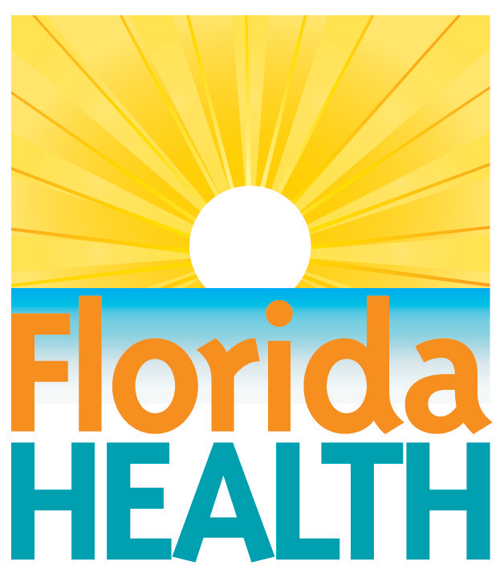

REGION 7 – Brevard, Collier, Glades, Hendry, Highlands, Indian River, Lee, Martin, Okeechobee, St. Lucie

Steve Krajewski
Florida Department of Health in St. Lucie County
5150 NW Milner Drive
Port St. Lucie, FL 34983
Phone: (772) 579-3546
E-mail : Steven.Krajewski@flhealth.gov

REGION 9 - Palm Beach

Catherine Jackson
Florida Department of Health in Palm Beach County
800 Clematis Street
West Palm Beach, FL 33401
Phone: (561) 671-4032
E-mail: Catherine.Jackson@flhealth.gov

REGION 10 - Broward
Love Ondusko-Levy
Florida Department of Health in Broward County
780 Southwest 24th Street, Ste. 207
Fort Lauderdale, FL 33315
Phone: (954) 847-8015
Phone : © (954) 806-3749
E-mail : Love.Ondusko-levy@flhealth.gov

REGION 11 - Miami-Dade, Monroe
Carmen Hernandez
Florida Department of Health in Miami-Dade County
8323 N.W. 12 Street, Ste. 212
Miami, Florida. 33126
Phone: (786) 336-1280
E-mail: Carmen.Hernandez3@flhealth.gov

