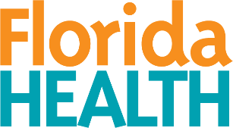
Florida Department of Health
Public Health Statistics and Performance Management
Primary Care Office

Physician Workforce Advisory Council
Strategic Planning Workgroup

Meeting Details February 17, 2026
Time: 9 – 10 am | Location: Teams
Purpose: Strategic Planning Workgroup – Meeting

Meeting Agenda
- Welcome | Dr. Debra Andree
- Objective Strategies | Dr. Debra Andree  Group Discussion
- Public Comments
- Next Meeting | Dr. Debra Andree  Keri Andersen Taggart

