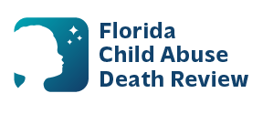
AGENDA
Circuit 6
Local Child Abuse Death Review Meeting
Teams Virtual Meetings:
January 9, 2026
February 13, 2026
March 13, 2026
June 12, 2026
September 11, 2026
November 13,2026
In-Person Meetings:
January 30, 2026
April 10, 2026
May 8, 2026
October 9, 2026
Time: 9:15 a.m. - 9:45 a.m. for both virtual and in-person
+1 239-984-6411 Phone Conference ID: 560 106 735# (Teams Virtual Meetings)
Juvenile Welfare Board, 14155 58th Street, N, Clearwater, FL 33760 (In-Person Meetings)

- Welcome and Introductions
- Local CADR Business
- CADR Program Updates
- Other Business
- Adjourn

