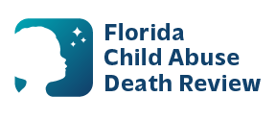
AGENDA
Circuit 11
Local Child Abuse Death Review Meeting
August meeting will be held on August 5, 2026, and November meeting will be held on November 18, 2026.
All other meetings will be held the second Wednesday of each month beginning January 14, 2026, 11:00 a.m. - 11:30 a.m.
Meeting location:
Zoom Meeting:
Meeting ID: 753 503 9156
Passcode: 13301

- Welcome and Introductions
- Local CADR Business
- CADR Program Updates
- Other Business
- Adjourn

