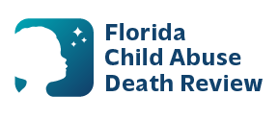
AGENDA
Circuit 15
Local Child Abuse Death Review Meeting
January through October, meetings will be held on the fourth Thursday of each month, from 9:00 a.m. to 9:15 a.m.
October and November meetings will be held on the third Thursday of those months, from 9:00 a.m. to 9:15 a.m.
Meeting location:
Florida Department of Health
800 Clematis Street, Room 2200
West Palm Beach, FL 33401

- Welcome and Introductions
- Local CADR Business
- CADR Program Updates
- Other Business
- Adjourn

