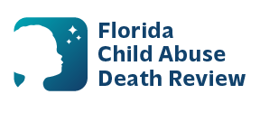
AGENDA
Circuit 13
Local Child Abuse Death Review Meeting
March 11, 2026
1:00 pm - 1:15 pm
Teams Meeting:
Meeting ID: 289 034 900 410 01
Passcode: 4U4k3Dd6

- Welcome and Introductions
- Local CADR Business
- CADR Program Updates
- Other Business
- Adjourn

