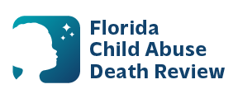
AGENDA
Circuit 13
Local Child Abuse Death Review Meeting
April 8, 2026
1:00 pm - 1:15 pm
Teams Meeting:
Meeting ID: 276 861 157 130 11
Passcode: HW7z9Tp6

- Welcome and Introductions
- Local CADR Business
- CADR Program Updates
- Other Business
- Adjourn

