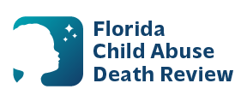
AGENDA
Circuit 8 Local Child Abuse Death Review Meeting
Meeting Date: March 31, 2026
Time: 1:00 p.m. – 1:15 p.m.
Meeting Place: Zoom
Meeting ID: 787 0024 7463
Passcode: 46kJCy

- Welcome and Introductions
- Local CADR Business
- CADR Program Updates
- Other Business
- Adjourn

