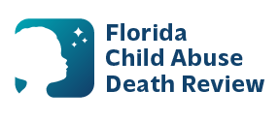
AGENDA
Circuit 12B Local Child Abuse Death Review Meeting
Meeting Date: March 30, 2026
Time: 2:00 p.m. - 2:15 p.m.
Meeting Place:
Sarasota DOH
2200 Ringling Blvd.
Sarasota, FL 34237

- Welcome and Introductions
- Local CADR Business
- CADR Program Updates
- Other Business
- Adjourn

