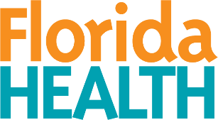
Florida Department of Health
Public Health Statistics and Performance Management
Primary Care Office

Physician Workforce Advisory Council
Strategic Planning Workgroup

Meeting Details June 05, 2026
Time: 11:30am – 12:30pm | Location: Teams
Purpose: Strategic Planning Workgroup – Meeting

Meeting Agenda
- Welcome | Dr. Debra Andree
- Strategies | Dr. Debra Andree  Group Discussion
- Public Comments
- Next Meeting | Dr. Debra Andree  Keri Andersen Taggart

