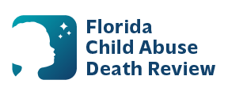
AGENDA
Circuit 13
Local Child Abuse Death Review Meeting
May 13, 2026
1:00 pm - 1:15 pm
Teams Meeting:
Meeting ID: 273 265 086 918 271
Passcode: 9hh9HV2Z

- Welcome and Introductions
- Local CADR Business
- CADR Program Updates
- Other Business
- Adjourn

