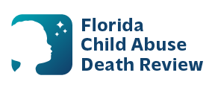
AGENDA
Circuit 9 Local Child Abuse Death Review Meeting
Meeting Date: April 24, 2026
Time: 1:00 PM – 1:30 PM
Orange County Medical Examiner
2350 E Michigan St
Orlando, Florida 32806

- Welcome and Introductions
- Local CADR Business
- CADR Program Updates
- Other Business
- Adjourn

