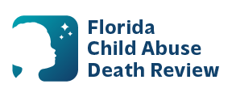
AGENDA
Circuit 9 Local Child Abuse Death Review Meeting
Meeting Dates:
July 17, 2026
August 14, 2026
October 11,2026
Time: 1:30 PM – 1:45 PM (for all meetings)
Manatee County Sheriff’s Office
District 2
3500 9th St. W.
Bradenton, Fl. 34205

- Welcome and Introductions
- Local CADR Business
- CADR Program Updates
- Other Business
- Adjourn

