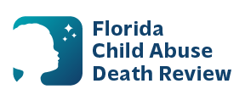
AGENDA
Circuit 13
Local Child Abuse Death Review Meeting
June 10, 2026
1:00 pm - 1:15 pm
Teams Meeting:
Meeting ID: 243 783 139 963 583
Passcode: VF2BF33K

- Welcome and Introductions
- Local CADR Business
- CADR Program Updates
- Other Business
- Adjourn

