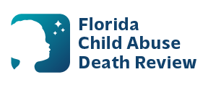
AGENDA
Circuit 4 Local Child Abuse Death Review Meeting
Date and Time:
June 18, 2026, 9:30 AM-9:45 AM
Microsoft Teams:
Meeting ID: 232 479 816 084 577
Passcode: J3mt6JZ7

- Welcome and Introductions
- Local CADR Business
- CADR Program Updates
- Other Business
- Adjourn

