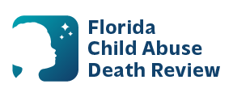
AGENDA
Circuit 4 Local Child Abuse Death Review Meeting
Date and Time:
August 14, 2026, 9:00 AM-9:15 AM
Meeting location:
Baptist Health Medical Center
Building A Suite 106
3563 Philips Highway
Jacksonville Fl 32207

- Welcome and Introductions
- Local CADR Business
- CADR Program Updates
- Other Business
- Adjourn

